|  |  |
| --- | --- |
|  | **MINISTRY OF EDUCATION AND TRAINING** |

**FPT UNIVERSITY**

|  |  |
| --- | --- |
| Capstone Project Document | |
| **Event Participant Tracking with GPS location and Image Capture at**  **FPTU** | |
| **Group 15 - IS** | |
| **Group members** | Phạm Quốc Bảo – SE62518 (Leader)  Đào Minh Hoàng – SE62406  Dương Tài Toàn – SE63438  Nguyễn Trần Hiển – SE62559 |
| **Supervisor** | Lâm Hữu Khánh Phương |
| **Ext. Supervisor** | Ngô Đặng Hà An |
| **Project Code** | FA20SE31 |

**-**  **Ho Chi Minh City, 13 January, 2020 -**

# **Table of contents**

Catalog

Table of contents 3

A. Report No. 1 Introduction 4

1. Project Information 4

2. Introduction 4

3. Current Situation 4

4. Problem definition 5

5. Proposed Solution 5

5.1 Feature functions 5

5.2 Values and challenges 5

6. Functional Requirements 5

7. Role and Responsibility 6

B. Report No. 2 Software Project Management Plan 6

1. Problem Definition 6

1.1 Name of this Capstone Project 6

1.2 Problem Abstract 7

1.3 Project Overview 7

2. Project Organization 9

2.1 Software Process Model 9

2.2 Roles and responsibilities 10

2.3 Tools and Techniques 11

3. Project Management Plan team tự update 12

3.1 Product Backlog 12

3.2 Sprint Backlog 12

3.3 Deliverables 12

3.4 All Meeting Minutes 13

4. Coding convention 13

C. Report No. 3 Software Requirement Specification 14

1.User Requirement Specification 14

1. Guest Requirement 14

2. Member Requirement 14

3. Service officer Requirement 14

4. Admin Requirement 14

2. System Requirement Specification 14

2.1 External Interface Requirement 14

2.2 System Overview Use Case 15

2.3 List of use case 16

3.Software System Attribute 59

4. Conceptual Diagram 60

Data Dictionary 60

D. Report No. 4 Software Design Description 61

1. Design Overview 61

2. System architecture design 61

3. Component diagram 62

3.1 Web application 63

3.2 C sharp server 64

3.3 Mobile 65

4. Detailed description 65

4.1 Class diagram 65

4.2 Class diagram explanation 67

4.3 Interaction Diagram 86

4.4 Sequence Diagram 90

5. Interface team tự update phân này 92

5.1 User Interface Design 92

6. Database Design 111

6.1 Entity relationship diagram (ERD) 111

6.2 Data dictionary 112

6.3 ERD Explanation 113

7. Algorithms 131

E. System Implementation & Test 131

1. Introduction 131

1.1 Overview 131

1.2 Test approach 131

2. Database Relationship Diagram 132

2.1 Physical Diagram 132

2.2 Data dictionary 132

3. Test plan 138

3.1 Features to be tested 138

3.2 Features not to be tested 138

4. System Testing Test Case 138

4.1 Communication Diagram 138

4.2 Test Case 139

F. Software User’s Manual 143

1. Installation Guide 143

1.1 Setting up environment at server side 143

1.2 Deployment at server side 144

1.3 Setting up environment at client side 151

2. User Guide 152

2.1 Guest 152

2.2 Member 156

2.3 Collaborator 156

2.4 Staff 156

2.5 Admin 156

2.5.1 Lock/unlock account 156

G. Appendix 157

# **A. Report No. 1 Introduction**

## 1. Project Information

* Project name: **Automated Event Participant Tracking with GPS location and Image Capture**
* Project Code: **FA20SE31**
* Product Type: **Web and Mobile Application**
* Start Date: **13/01/2020**
* End Date: **02/5/2020**

## 2. Introduction

As students of FPT University, we know our university has many events are held continually to connect the community, bring new knowledge to students, … And we all know how hard it is to organize and manage events, so we decided to take this project and create a system to help our university get easier in manage events.

## 3. Current Situation

“At FPT University, there are many events organized by clubs, departments, or in conjunction with enterprises from outside. Students participate in many events held at the school. However, the registration and participation process is managed manually and via excel, so it takes a lot of time to synthesize and evaluate the results of events.”

## 4. Problem definition

**Manually and Via Excel are still commonly being used since there are some values:**

* The traditional way from elder
* Easy to implement
* Low cost.

**But these ways have some challenges:**

* It easy to lose a file.
* Take a lot of time to manage event with a tone of repetitive actions.
* Impossible to catch up with student attendance.
* Limit student interaction

## 5. Proposed Solution

* We propose a solution for building the APT system that includes a web application for the event organizer and a mobile app for students to sign up. Via this system, information about events will be up to date for students on time, event information will be centrally managed for efficiency analysis and evaluation.

### 5.1 Feature functions

* System supports users to manage convenience and effective events.
* System supports users to track the student interaction with the event is holding

### 5.2 Values and challenges

* Values:
* Save time for the registration and participation process.
* Easy to tracking interaction of student.
* Optimize store and manage events information
* Challenges:
* Participants may not use the system while participating events (unintentionally and intentionally)
* Students may turn off location service while participating events.
* Student locations tracking cannot be 100% accurate.

## 6. Functional Requirements

Function requirements of the system are listed as below:

* Student Mobile App
* This application is meant for students who participates events.
* Student login to the system by @fpt.edu.vn email
* Student can view list of events in past and future.
* Student can register to event
* Student check in event by his application. When checking in, his image and GPS location will be captured and sent to the server. ▪
* Some events have the right to require participants to turn on Always On mode to prove their presence in the event. In this mode, GPS location of the user will be tracked automatically by the system and sent to the admin after every 5 minutes.
* Student can view history of event participant..
* Admin Web System
* Organizers can manage events organized in FPTU.
* Organizers can accept/deny student’s registration in a specific event.
* Organizers can keep track event participants list in Always On mode every 5 minutes. Organizers can view image and GPS location of participants in web application.
* The system has reported for events and student participants.
* Report have to export to excel with necessary information.

## 7. Role and Responsibility

|  |  |  |  |
| --- | --- | --- | --- |
|  | *Full Name* | *Position* | *Contact* |
| *1* | *Lâm Hữu Khánh Phương* | *Supervisor* | *phuonglhk@fpt.edu.vn* |
| *2* | *Ngô Đặng Hà An* | *Extra Supervisor* | *@fe.edu.vn* |
| *3* | *Phạm Quốc Bảo* | *Leader* | *baopqse62518@fpt.edu.vn* |
| *4* | *Nguyễn Thành Dũng* | *Member* | *dungntse62406@fpt.edu.vn* |
| *5* | *Dương Tài Toàn* | *Member* | *toandtse63438@fpt.edu.vn* |
| *6* | *Nguyễn Trần Hiển* | *Member* | *hienntse62559@fpt.edu.vn* |

# **B. Report No. 2 Software Project Management Plan**

## 1. Problem Definition

### 1.1 Name of this Capstone Project

* Official name: Event Participant Tracking with GPS location and Image Capture at FPTU.
* Vietnamese name: Hệ thống quản lý tham gia sự kiện tại ĐH FPT bằng định vị GPS và hình ảnh.
* Abbreviation: APT

### 1.2 Problem Abstract

* This project is concerned about how help organizer manage events more effectively and save time the registration and participation process. We will provide a system called APT which can help solving this problem.
* we must face and solve the problem that how to tracking student are in events or not. These are all new things our system will bring to users in order to manage events.

### 1.3 Project Overview

#### 1.3.1 Current Situation

**Below are the problems encountered in this project:**

* Time and human resource limitation: Only 4 team members and about 13 or 15 weeks to prepare documents, implement the product.
* New techniques such as ASP.NET,and Flutter: Some members are unfamiliar with the techniques used in the project, need time to get used to with those techniques.
* Conflict during project working time: idea conflict, time conflict, method conflict;...

#### 1.3.2 The Proposed System

* We build a system supporting tracking students present in events space.
* We also build a system which can manage events, evaluation through report
* Our system includes mobile applications for student, web applications for administrators.
* The output of this project:

· Mobile application

· Web application

#### 1.3.2.1 Mobile application

**For guest**

* Guest can login

**For Student**

* Student can register events.
* Student can view list register.
* Student can cancel request register
* Student check in an event

#### 1.3.2.2 Web admin

**For admin**

* Admin can manage service officer accounts.

**For Service officer**

* Service officer can manage participants.
* Service officer can create event.
* Service officer can track user present
* Service officer can delete event
* Service officer can view register list
* Service officer can reject or approve registration
* Service officer can edit event
* Service officer can check in by manually for participants

**For system handler**

* System can send tracking information.
* System can send email notification

#### 1.3.3 Boundaries of the System

**The system should do:**

* Supports users to manage event.
* Supports users to track student information

**The system should not do:**

* Validate the availability of the user’s contributed route
* Validate the present current location of student

#### 1.3.4 Future Plans

* Research another algorithm for detecting student location.

- Support more methods to check in more easy and effective.

#### 1.3.5 Development environment

**1.3.5.1 Hardware requirements**

***For server***

|  |  |  |
| --- | --- | --- |
| **Server** | **Minimum Requirements** | **Recommended** |
| **Internet Connection** | Cable, Wi-Fi (8 Mbps) | Cable, Wi-Fi (50 Mbps or more) |
| **Operating System** | 10, Window Server 2016 | 10, Window Server 2016 |
| **Computer Processor** | Intel® Xeon ® 1.4GHz | Intel® Xeon ® Quad Core (12M Cache, 2.50 GHz) |
| **Computer Memory** | 4GB RAM | 32GB or more |
| **Storage space** | 5GB | 10GB or more |

***For mobile***

|  |  |  |
| --- | --- | --- |
| **Server** | **Minimum Requirements** | **Recommended** |
| **Internet Connection** | Wi-Fi | Wi-Fi |
| **Operating System** | Android API > 27 | Android API > 27 |
| **Mobile Processor** | 4 Core 2 GHz | 8 Core 2ghz |
| **Mobile Memory** | 2GB RAM | 3GB RAM or more |

**Table 3: Hardware Requirement for Mobile**

**1.3.5.2 Software requirements**

|  |  |  |
| --- | --- | --- |
| **Name** | **Name/Version** | **Description** |
| **Operating System** | Window 10 | Operating system and platform for development |
| **Modeling tool** | StarUML | Used to design diagram |
| **IDE** | Visual Studio, Visual Studio Code, Android Studio | Programming tools |
| **DBMS** | SQL Server 2019 | Used to create & manage the database for system |
| **Web server** | Microsoft Azure | Deployment environment |
| **Source control** | Github | Used for source control |
| **Web browser** | Chrome 79 or above. | Testing browser |

## 2. Project Organization

### 2.1 Software Process Model

#### What is agile?

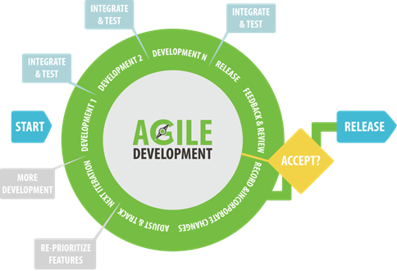

Figure 1- Software Process Model

Reference: <https://www.agilealliance.org/>

#### What is SCRUM?

Reference: <https://scrumguides.org/>

#### Why is SCRUM?

We use Scrum to develop our project. We decide to use Scrum to be consistent with the current situation in our team. We choose this model due to following reasons:

* Our team only has 4 members, and tasks are assigned vertically, doing all steps from design, coding, testing and implementation. Scrum is the most suitable model for small and medium projects.
* Product status is also a reason why we decide to use Scrum. Because of change, some factors can cause risks such as people, technology in the early stages, we found that Scrum fits this projects most this problem
* The project contains a complicated system and the concept of machine learning is quite new for us, so we need to try many designs before the system runs stability.
* In the project there are many new technologies that need to be learned such as NET Core, Flutter, ASP.NET. With the Scrum model, the team can learn new techs and apply to project in order to catch up on schedule.
* Product Owner can change requirements or extend scope. The team will adapt to change better.

### 2.2 Roles and responsibilities

|  |  |  |  |
| --- | --- | --- | --- |
| **No** | **Role in Scrum** | **Name** | **Responsibilities** |
| 1 | **Product owner** | Lâm Hữu Khánh Phương  Ngô Đặng Hà An | · Specify scope and user requirement.  · Control the development progress.  · Give out techniques and business analysis support. |
| 2 | **Scrum master** | Phạm Quốc Bảo | · Managing process  · Create test plan  · Arrange meeting  · Implement Reinforcement learning  · Clarifying requirements  · GUI Design  . Risk Management  · Coding  · Testing  . Designing database  . Prepare documents |
| 3 | **Scrum team member** | Nguyễn Thành Dũng  Nguyễn Thành Dũng  Nguyễn Trần Hiển | · Designing database  · Clarifying requirements  · Prepare documents  · GUI design  · Coding  · Testing  . Prepare documents |

Table 5: Roles and responsibilities details

### 2.3 Tools and Technologies

|  |  |
| --- | --- |
| Tool/Technique | Name |
| Front-end | Dart, Javascript,C#, Flutter, ASP.NET |
| Back-end | .NET Core |
| IDE | Visual Studio, Visual Studio Code, Android Studio |
| DBMS | SQL Server |
| Source Control | Github |
| Modelling tool | Atlassian Jira |

Table 6: Tools and techniques

## 3. Project Management Plan team tự update

### 3.1 Product Backlog

Product Backlog could be found [here](https://github.com/nguyentranhien/apt-documents).

### 3.2 Sprint Backlog

Sprint Backlog can be found [here](https://github.com/nguyentranhien/apt-documents).

### 3.3 Deliverables

|  |  |  |
| --- | --- | --- |
| **No** | **Deliverable** | **Note** |
| 1 | Report 1, algorithm report, study Google API, study ReactJS | Sprint 1 |
| 2 | Report 2, Study 3-tier architect (Client - Server - Database), SpringBoot, JPA, Hibernate | Sprint 2 |
| 3 | View the map, Zoom in/out the map, Login functions | Sprint 3 |
| 4 | Find a location function, | Sprint 4 |
| 5 | View searched locations history, Find a route, Add/remove/view/contribute the private routes functions | Sprint 5 |
| 6 | View a detail location information, Disable/enable user account, Report/cancel traffic jam functions | Sprint 6 |
| 7 | Find an alternative route, View a detail route information functions, Report 3 and Report 4 | Sprint 7 |
| 8 | Accept/decline user adding new private route, Send alter-route request to user functions | Sprint 8 |
| 9 | Report 5 | Sprint 9 |
| 10 | Navigate by voice, Clear/set traffic jam of system functions and Report 6 | Sprint 10 |
| 11 | Execute unit test report, Execute integration test reported, Full-document, Slide for review 1 | Sprint 11 |
| 12 | Tile server | Sprint 12 |
| 13 | Change to OpenStreetTiles function | Sprint 13 |
| 14 | Slide | Sprint 14 |

Table 7: Deliverables

### 3.4 All Meeting Minutes

All sprint meeting minutes could be found [here](https://github.com/nguyentranhien/apt-documents).

## 4. Coding convention

**C# Convention:**

* Naming convention : [https://docs.microsoft.com/en-us/dotnet/csharp/programming-guide/inside-a-program/coding-conventions#naming-conventions](https://docs.microsoft.com/en-us/dotnet/csharp/programming-guide/inside-a-program/coding-conventions" \l "naming-conventions)
* Layout Convention: [https://docs.microsoft.com/en-us/dotnet/csharp/programming-guide/inside-a-program/coding-conventions#layout-conventions](https://docs.microsoft.com/en-us/dotnet/csharp/programming-guide/inside-a-program/coding-conventions" \l "layout-conventions)
* Commenting Convention: [https://docs.microsoft.com/en-us/dotnet/csharp/programming-guide/inside-a-program/coding-conventions#commenting-conventions](https://docs.microsoft.com/en-us/dotnet/csharp/programming-guide/inside-a-program/coding-conventions" \l "commenting-conventions)
* Language Guidelines: [https://docs.microsoft.com/en-us/dotnet/csharp/programming-guide/inside-a-program/coding-conventions#language-guidelines](https://docs.microsoft.com/en-us/dotnet/csharp/programming-guide/inside-a-program/coding-conventions" \l "language-guidelines)
* Security: [https://docs.microsoft.com/en-us/dotnet/csharp/programming-guide/inside-a-program/coding-conventions#security](https://docs.microsoft.com/en-us/dotnet/csharp/programming-guide/inside-a-program/coding-conventions" \l "security)

**JavaScript Convention Rules:**

**Flutter Convention Rules:**

[https://dart.dev/guides/language/effective-dart/style](https://www.w3schools.com/js/js_conventions.asp)

# **C. Report No. 3 Software Requirement Specification**

## 1.User Requirement Specification

### 1. Guest Requirement

*Guest is a person who doesn’t have permission to access the system. To use all functions, guest must login. These are some functions guest can use:*

* Login

### 2. Member Requirement

*Member is an authorized user who has permission to login into the system under member role. With member role, user can use below functions:*

* Register events
* Cancel register request
* Check in by QA code
* Get event list

### 3. Service officer Requirement

*Service officer is an authorized user who has permission to login into the system under collaborator role. Collaborator can use below functions:*

* Create event
* Get event list
* Get list registration
* Edit an event
* Cancel or approve registration
* Get QR code
* Check in manual
* Track student information

### 4. Admin Requirement

*Admin is an authorized user who has permission to login into the system under admin role. Admin can use below functions:*

* Manage service officer
* Manage event
* Manage registration

## 2. System Requirement Specification

### 2.1 External Interface Requirement

#### 2.1.1 User Interface

* GUI should be simple, clear,and intuitive.
* The interface design is an iterate process including: design, sketching, prototyping, user assessment.
* The User Interface uses language is English.

#### 2.1.2 Hardware Interface

* Smart phone.
* Computer

#### 2.1.3 Software Interface

* Web application: work with browsers Chromium-based browsers, Firefox and also Safari
* Mobile application: work with Android version with API > 27

#### 2.1.4 Communication Protocol

* Use HTTPS protocol 1.1 for communication between:

Web application and web server

Mobile application and web server

### 2.2 System Overview Use Case

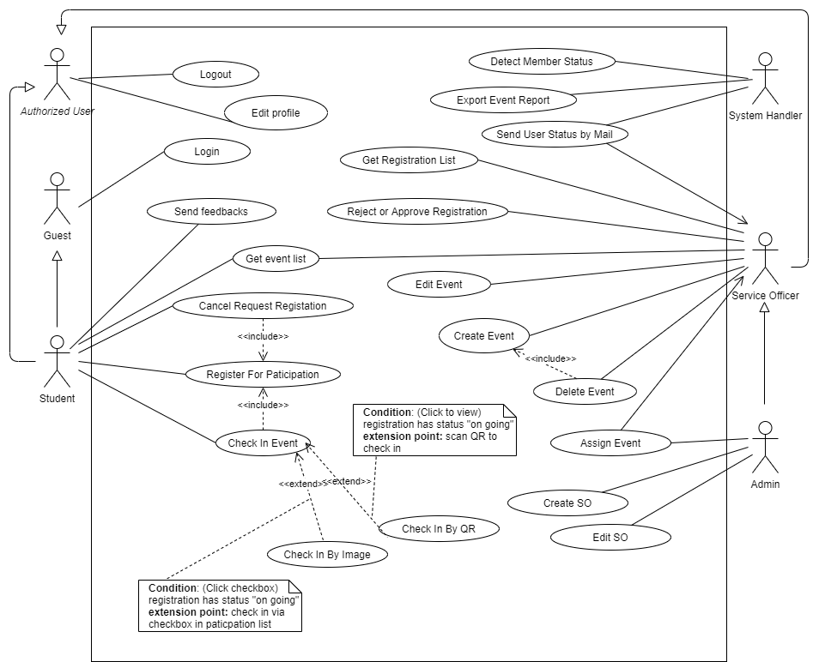

**Figure 2: System overview use case**

### 2.3 List of use case

#### 2.3.1 <Guest> Overview Use Case

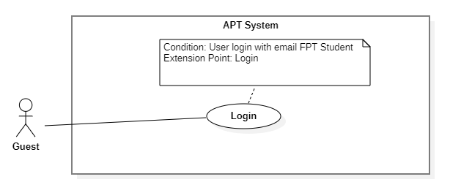

**Figure 3: Guest overview use case**

#### 2.3.1.1 <Guest> Login



**Figure 4: <Guest> login use case**

|  |  |  |  |
| --- | --- | --- | --- |
| **USE CASE – APT_1_1** | | | |
| **Use Case No.** | APT_1_1 | **Use Case Version** | 2 |
| **Use Case Name** | Login | | |
| **Author** |  | | |
| **Date** | 10/2/2020 | **Priority** | Medium |
| **Actor:**   * Guest   **Summary:**   * This use case allows guest to login to the system   **Goal:**   * Guest can login to the system   **Triggers:**   * Guest sends login command.   **Preconditions:**   * N/A   **Post conditions:**   * Success: System redirects to the specific role’s main screen. * Fail: System shows error messages.   **Main Success Scenario:**   |  |  |  | | --- | --- | --- | | **Step** | **Actor Action** | **System Response** | | 1 | Guest goes to login view | System requires identity information from guest:  “Username”: Text Input  “Password”: Text Input | | 2 | Guest inputs information |  | | 3 | Guest sends login command | Guest will login to the system with their specific role  [Alternative 1]  [Exception 1] |   **Alternative Scenario:**   |  |  |  | | --- | --- | --- | | **No** | **Actor Action** | **System Response** | | 1 | Guest enters wrong identity information | Wrong identity information, system shows error message |   **Exceptions:**   |  |  |  | | --- | --- | --- | | **No** | **Cause** | **System Response** | | 1 | Guest’s email is existed in the system | System shows message to notify guest that their email is existed in the system |   **Relationships:** N/A  **Business Rules:**   * Password must be encrypted before sending to the server * After login to the system, guest will be redirected to specific view based on their role on the system: member, admin, staff or collaborator * If role is “Member”, the system will redirect to Member View * If role is “Admin”, the system will redirect to Admin View * If role is “Student Service Officer”, the system will redirect to Student Service Officer View | | | |

**Table 8: <Guest> Login**

#### 2.3.2 <Student> Overview Use Case

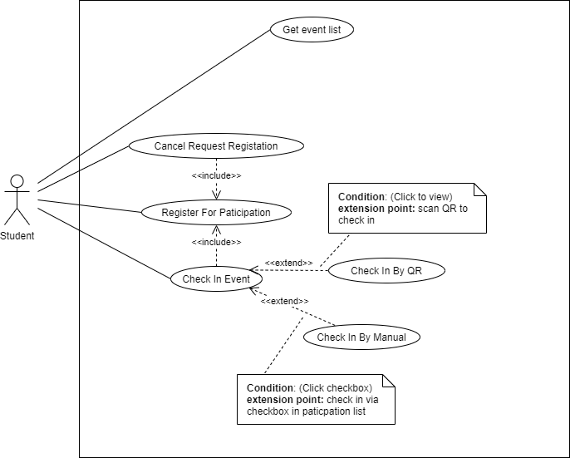

**Figure 5: <Student>overview use case**

#### 2.3.2.1 <Student> Register Event

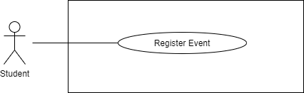

**Figure 6: <Student> Register use case**

|  |  |  |  |
| --- | --- | --- | --- |
| **USE CASE – APT_2_1** | | | |
| **Use Case No.** | APT_1_2 | **Use Case Version** | 2 |
| **Use Case Name** | Register Event | | |
| **Author** | Student | | |
| **Date** | 19/11/2020 | **Priority** | High |
| **Actor:**   * Student   **Summary:**   * This use case allows Student to register event in the system   **Goal:**   * Student can register event to the system   **Triggers:**   * Student sends register event command.   **Preconditions:**   * User’s identity has been authenticated * The event has been approved and must not be expired/opened * The student has not registered for the event before.   **Post conditions:**   * Success: System redirects to the event detail page. * Fail: System shows error messages.   **Main Success Scenario:**   |  |  |  | | --- | --- | --- | | **Step** | **Actor Action** | **System Response** | | 1 | Student clicks an event from home page on APT Mobile Application. | System redirects student to the event detail page which shows details for the selected event. | | 2 | Student clicks “Register” | System shows a confirmation dialog | | 3 | Student confirms by clicking “Yes” | System creates a registration and saves it into database System shows the information dialog which tells admin/SO that the event has been saved successfully. |   **Alternative Scenario:**  N/A  **Exceptions:**   |  |  |  | | --- | --- | --- | | **No** | **Cause** | **System Response** | | 1 | Student register already | The student has not registered for the event before. | |  | Student input invalid information | System encounters errors while saving registrations to database. System will then show a toast which tells user the short description of error, and then requires user to retry. |   **Relationships:** N/A  **Business Rules:**   * Refer to User Story 02 | | | |

**Table 9: <Student> Register Event**

#### 2.3.2.2 <Student> Get list event

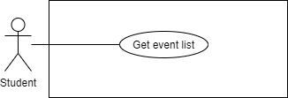

**Figure 7: <Student> Get list event use case**

|  |  |  |  |
| --- | --- | --- | --- |
| **USE CASE – APT_2_2** | | | |
| **Use Case No.** | APT_2_2 | **Use Case Version** | 2 |
| **Use Case Name** | Get list event | | |
| **Author** | Nguyễn Trần Hiển | | |
| **Date** | 12/2/2020 | **Priority** | Medium |
| **Actor:**   * Student   **Summary:**   * This use case allows admin to get all event   **Goal:**   * Student can view all event list   **Triggers:**   * Student sends get events command   **Preconditions:**   * User’s identity has been authenticated.   **Post conditions:**   * Success: System redirects Admin to list event page. * Fail: System shows error messages.   **Main Success Scenario:**   |  |  |  | | --- | --- | --- | | **Step** | **Actor Action** | **System Response** | | 1 | Student navigates to Home/Events page on APT Mobile Application. | Student navigates to Home/Events page on APT Mobile Application. | |  | Student can search/filter for results | System the result page |   **Alternative Scenario:** N/A  **Exceptions:**   |  |  |  | | --- | --- | --- | | **No** | **Cause** | **System Response** | | 1 | System encounters errors while authenticating guest user. | System will then show a toast which tells guest user that they need to authenticate again. | | 2 | System encounters errors while saving events to database. | System will then show a toast which tells user the short description of error, and then requires user to repeat the action |   **Relationships:**   * N/A   **Business Rules:**  Refer to User Story 02 | | | |

**Table 11: <Student> Get event list**

#### 2.3.2.3 <Student> Feedback event

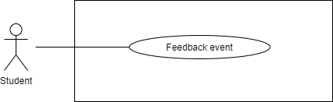

**Figure 9: <Student>Feedback event use case**

|  |  |  |  |
| --- | --- | --- | --- |
| **USE CASE – APT_2_4** | | | |
| **Use Case No.** | APT_2_4 | **Use Case Version** | 2 |
| **Use Case Name** | Feedback event | | |
| **Author** | Nguyễn Trần Hiển | | |
| **Date** | 9/28/2020 | **Priority** | High |
| **Actor:**   * Student   **Summary:**   * This use case allows Student to send feedback about vent.   **Goal:**   * Student can send feedback about event   **Triggers:**   * Student sends feedback event command   **Preconditions:**   * User’s identity has been authenticated   **Post conditions:**   * Success: System redirects student to the home page which shows all his/her event registrations. * Fail: Show error message   **Main Success Scenario:**   |  |  |  | | --- | --- | --- | | **Step** | **Actor Action** | **System Response** | | 1 | Student navigates to feedback page on APT Mobile Application | System redirects student to the feedback page which shows all his/her feedback form | | 2 | Student can comment about event and click send | System will show message and redirect student to home page |   **Alternative Scenario:** N/A  **Exceptions:**   |  |  |  | | --- | --- | --- | | **Step** | **Cause** | **System Response** | | 1 | System encounters errors while authenticating guest user. | System will then show a toast which tells guest user that they need to authenticate again. | | 2 | System encounters errors while fetching registrations from database. | System will then show a toast which tells user the short description of error, and then requires user to refresh the page. |   **Relationships:** N/A  **Business Rules:**   * Refer to User Story 03 | | | |

**Table 13: <Student>Feedback event**

#### 2.3.2.4 <Student> Check-in an Event

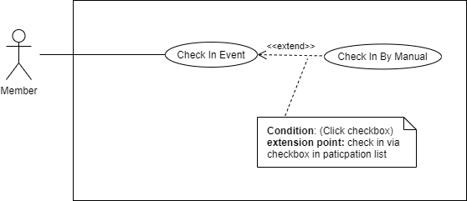

**Figure 10: <Student>Check in an event use case**

|  |  |  |  |
| --- | --- | --- | --- |
| **USE CASE – APT_2_5** | | | |
| **Use Case No.** | APT_2_5 | **Use Case Version** | 2 |
| **Use Case Name** | Check-in an Event | | |
| **Author** | Nguyễn Trần Hiển | | |
| **Date** | 9/30/2020 | **Priority** | High |
| **Actor:**   * Student   **Summary:**   * This use case allows Student to check in an event   **Goal:**   * Student can check in an event   **Triggers:**   * Student sends check in an event command   **Preconditions:**   * Student check-in event information has been saved to database * Student status will be updated after the check-ins and after the events end   **Post conditions:**   * Success:   + Student check-in event information has been saved to database  + Student status will be updated after the check-ins and after the events end   * Fail: System shows error message.   **Main Success Scenario:**   |  |  |  | | --- | --- | --- | | **Step** | **Actor Action** | **System Response** | | 1 | Student clicks a “Check-in” on a registration from Registrations page on APT Mobile Application. | System shows a confirmation dialog. | | 2 | Student confirms by clicking “Yes” on the dialog. | System requests student to allow access to camera & location if the two permissions are not given by student before | | 3 | Student gives system permissions to access camera and location. | System requests student to take a picture which is similar to the reference picture of the event. | | 4 | Student takes a picture as requested. | - System gets location information using GPS and save the check-in information into database.  - System updates status of student to IN_EVENT and saves changes to database.  - System shows an information dialog to tell student that he/she has checked in the event successfully.  - After the event ends, system updates student status back to normal and saves changes to database. |   **Alternative Scenario:**  **N/A**  **Exceptions:**   |  |  |  | | --- | --- | --- | | **No** | **Cause** | **System Response** | | 1 | System encounters errors while authenticating guest user. | System will then show a toast which tells guest user that they need to authenticate again. | | 2 | System encounters errors while taking picture/asking for permissions/getting location/saving check-in information to database. | System will then show a toast which tells user the short description of error, and then requires user to repeat the action. |   **Relationships:** N/A  **Business Rules:**   * Refer to User Story 04 | | | |

**Table 14: <Student> Check-In An Event**

#### 2.3.2.5 <Student> Check In An Event By QR

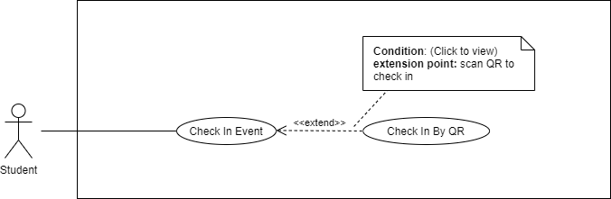

**Figure 11: <Student>Check in an event by QR use case**

|  |  |  |  |
| --- | --- | --- | --- |
| **USE CASE – APT_2_6** | | | |
| **Use Case No.** | APT_2_6 | **Use Case Version** | 2 |
| **Use Case Name** | Check-in an event by QR | | |
| **Author** | Nguyễn Trần Hiển | | |
| **Date** | 9/30/2020 | **Priority** | High |
| **Actor:**   * Student   **Summary:**   * This use case allows Student to check in an event   **Goal:**   * Student can check in an event   **Triggers:**   * Student sends check in an event command   **Preconditions:**   * Student check-in event information has been saved to database * Student status will be updated after the check-ins and after the events end   **Post conditions:**   * Success:   + Student check-in event information has been saved to database  + Student status will be updated after the check-ins and after the events end   * Fail: System shows error message.   **Main Success Scenario:**   |  |  |  | | --- | --- | --- | | **Step** | **Actor Action** | **System Response** | | 1 | Student clicks a “Check-in by QR” on a registration from Registrations page on APT Mobile Application. | System shows a confirmation dialog. | | 2 | Student confirms by clicking “Yes” on the dialog. | System requests student to allow access to camera & location if the two permissions are not given by student before | | 3 | Student gives system permissions to access camera and location. | System requests student to take a picture which is similar to the reference picture of the event. | | 4 | Student takes a picture as requested. | - System gets location information using GPS and save the check-in information into database.  - System updates status of student to IN_EVENT and saves changes to database.  - System shows an information dialog to tell student that he/she has checked in the event successfully.  - After the event ends, system updates student status back to normal and saves changes to database. |   **Alternative Scenario:**  **N/A**  **Exceptions:**   |  |  |  | | --- | --- | --- | | **No** | **Cause** | **System Response** | | 1 | System encounters errors while authenticating guest user. | System will then show a toast which tells guest user that they need to authenticate again. | | 2 | System encounters errors while taking picture/asking for permissions/getting location/saving check-in information to database. | System will then show a toast which tells user the short description of error, and then requires user to repeat the action. |   **Relationships:** N/A  **Business Rules:**   * Refer to User Story 04 | | | |

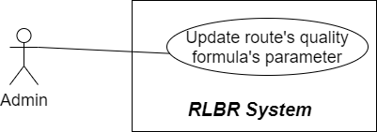

**Table 15:<Student> Check-In An Event By QR**

#### 2.3.2.6 <Student> Cancel Registration

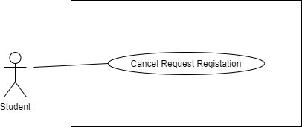

**Figure 12: <Student> Cancel registration use case**

|  |  |  |  |
| --- | --- | --- | --- |
| **USE CASE- APT_2_7** | | | |
| **Use Case No.** | APT_2_7 | **Use Case Version** | 2 |
| **Use Case Name** | Cancel registration | | |
| **Author** | Nguyễn Trần Hiển | | |
| **Date** | 12/2/2020 | **Priority** | High |
| **Actor:**   * Student   **Summary:**   * This use case allows Student to find cancel registration   **Goal:**   * Student can cancel registration   **Triggers:**   * Student sends request cancel registration to the system   **Preconditions:**   * User’s identity has been authenticated * Student has request registration   **Post conditions:**   * Success: User’s identity has been authenticated * Fail: System shows error messages.   **Main Success Scenario:**   |  |  |  | | --- | --- | --- | | **Step** | **Actor Action** | **System Response** | | 1 | Student clicks a “Cancel” on a registration from Registrations page on APT Mobile Application. | System shows a confirmation dialog.. | | 2 | Student confirms by filling the reason and clicking “Yes” on the dialog.] | System updates the status of the registration and saves it to database.  System updates the status of the registration and saves it to database. |   **Alternative Scenario:** N/A  **Exceptions:**   |  |  |  | | --- | --- | --- | | **No** | **Cause** | **System Response** | | 1 | System encounters errors while authenticating guest user. | System shows error message for guest System will then show a toast which tells guest user that they need to authenticate again. | | 2 | System encounters errors while fetching registrations from database. | System will then show a toast which tells user the short description of error, and then requires user to refresh the page. |   **Relationships:** Find alternative route, Get a detail route information, Navigate  **Business Rules:**  Refer to User Story 03 | | | |

**Table 16: <Student> Cancel Registration**

#### 2.3.3 <Service Officer> Overview user case

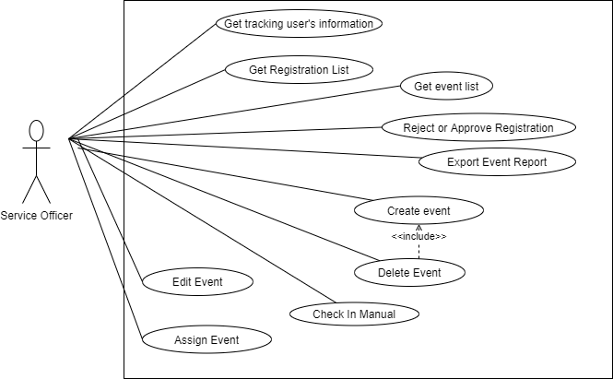

**Figure 13: <Service officer> Overview use case**

#### 2.3.3.1 <Service Officer> Get Event List

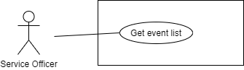

**Figure 14: <Service officer> Get event list use case**

|  |  |  |  |
| --- | --- | --- | --- |
| **USE CASE – APT_3_1** | | | |
| **Use Case No.** | APT_3_1 | **Use Case Version** | 2 |
| **Use Case Name** | Get list event | | |
| **Author** | Nguyễn Trần Hiển | | |
| **Date** | 12/2/2020 | **Priority** | Medium |
| **Actor:**   * Service officer   **Summary:**   * This use case allows admin to get all event   **Goal:**   * Service officer can view all event list   **Triggers:**   * Service officer sends get events command   **Preconditions:**   * User’s identity has been authenticated.   **Post conditions:**   * Success: System redirects Admin to list event page. * Fail: System shows error messages.   **Main Success Scenario:**   |  |  |  | | --- | --- | --- | | **Step** | **Actor Action** | **System Response** | | 1 | Admin/ service officer navigates to Home/Events page on APT Web Application. | Admin/service officer navigates to Home/Events page on APT Web Application. | |  | Admin/service officer navigates to Home/Events page on APT Web Application. | System the result page |   **Alternative Scenario:** N/A  **Exceptions:**   |  |  |  | | --- | --- | --- | | **No** | **Cause** | **System Response** | | 1 | System encounters errors while authenticating guest user. | System will then show a toast which tells guest user that they need to authenticate again. | | 2 | System encounters errors while saving events to database. | System will then show a toast which tells user the short description of error, and then requires user to repeat the action |   **Relationships:**   * N/A   **Business Rules:**  Refer to User Story 02 | | | |

**Table 17: <Service officer> Get event list**

#### 2.3.3.2 <Service Officer> Get Event



**Figure 15: <Service officer> Get event details use case**

|  |  |  |  |
| --- | --- | --- | --- |
| **USE CASE – APT_3_2** | | | |
| **Use Case No.** | APT_3_2 | **Use Case Version** | 2 |
| **Use Case Name** | View event detail | | |
| **Author** | Nguyễn Trần Hiển | | |
| **Date** | 12/2/2020 | **Priority** | High |
| **Actor:**   * Service officer   **Summary:**   * This use case allows admin to view event details.   **Goal:**   * Service officer can view even details   **Triggers:**   * Service officer sends view event details command   **Preconditions:**   * User’s identity has been authenticated   **Post conditions:**   * Success: System redirects Admin/SO to the event detail page which shows details for the selected event.   **Main Success Scenario:**   |  |  |  | | --- | --- | --- | | **Step** | **Actor Action** | **System Response** | | 1 | Admin/service officer clicks an event from home page on APT Web Application. | System redirects Admin/Service officer to the event detail page which shows details for the selected event |   **Alternative Scenario:**  **N/A**  **Exceptions:**   |  |  |  | | --- | --- | --- | | **No** | **Cause** | **System Response** | | 1 | System encounters errors while authenticating guest user. | System will then show a toast which tells guest user that they need to authenticate again. |   **Relationships:**  **Business Rules:**   * Refer to User Story 02 | | | |

**Table 18: <Service officer> Get Event**

#### 2.3.3.3 <Service Officer> Edit Event

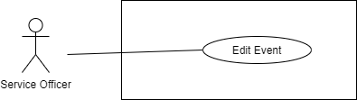

**Figure 16: <Service officer> Edit event use case**

|  |  |  |  |
| --- | --- | --- | --- |
| **USE CASE – APT_3_3** | | | |
| **Use Case No.** | APT_3_3 | **Use Case Version** | 2 |
| **Use Case Name** | Navigate | | |
| **Author** | Ngô Gia Huy | | |
| **Date** | 12/2/2020 | **Priority** | Medium |
| **Actor:**   * Service officer   **Summary:**   * This use case allows guest to be navigated   **Goal:**   * Service officer can edit event   **Triggers:**   * Service officer sends edit event command   **Preconditions:**   * User’s identity has been authenticated   **Post conditions:**   * Success: System redirects admin/SO to the event detail page which shows details for the selected event.   **Main Success Scenario:**   |  |  |  | | --- | --- | --- | | **Step** | **Actor Action** | **System Response** | | 1 | Admin/service officer clicks an event from home page on APT Web Application | System redirects admin/Service officer to the event detail page which shows details for the selected event. | | 2 | Admin/service officer edits the event  Admin/Service officer clicks “Save” | System shows a confirmation dialog | | 3 | Admin/service officer confirms by clicking “Save”. | System saves the event to database.  System shows the information dialog which tells admin/Service officer that the event has been saved successfully. |   **Alternative Scenario:** N/A  **Exceptions:**   |  |  |  | | --- | --- | --- | | **No** | **Cause** | **System Response** | | 1 | System encounters errors while authenticating guest user. | System will then show a toast which tells guest user that they need to authenticate again. | | 2 | System encounters errors while saving events to database. | System will then show a toast which tells user the short description of error, and then requires user to retry. |   **Relationships:**   * Extend from use case: Get the map   **Business Rules:**   * Refer to User Story 01 | | | |

**Table 19: <Service officer> Edit Event**

#### 2.3.3.4 <Service Officer> Get Registration List

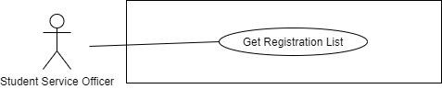

**Figure 17 <Service officer> Get Registration list use case**

|  |  |  |  |
| --- | --- | --- | --- |
| **USE CASE – APT_3_4** | | | |
| **Use Case No.** | APT_3_4 | **Use Case Version** | 2 |
| **Use Case Name** | View Event Registrations | | |
| **Author** | Nguyễn Trần Hiển | | |
| **Date** | 9/28/2020 | **Priority** | High |
| **Actor:**   * Service officer   **Summary:**   * This use case allows member to view events registration.   **Goal:**   * Admin/Service officer can events registration   **Triggers:**   * Admin/Service officer sends view events registration command   **Preconditions:**   * User’s identity has been authenticated   **Post conditions:**   * Success: System redirects admin/SO to the Registrations page which shows all event registrations * Fail: Show error message   **Main Success Scenario:**   |  |  |  | | --- | --- | --- | | **Step** | **Actor Action** | **System Response** | | 1 | Admin/Service officer navigates to Registrations page on APT Web Application | System redirects admin/Service officer to the Registrations page which shows all event registrations. | | 2 | System redirects admin to the Registrations page which shows all event registrations. | System displays the result search |   **Alternative Scenario:** N/A  **Exceptions:**   |  |  |  | | --- | --- | --- | | **Step** | **Cause** | **System Response** | | 1 | System encounters errors while authenticating guest user. | System will then show a toast which tells guest user that they need to authenticate again. | | 2 | System encounters errors while fetching registrations from database. | System will then show a toast which tells user the short description of error, and then requires user to refresh the page. |   **Relationships:** N/A  **Business Rules:**   * Refer to User Story 03 | | | |

**Table 20: <Service officer> Get registration list**

#### 2.3.3.5 <Service Officer> Check-in an Event



**Figure 18: <Service officer> Check in an event user case**

|  |  |  |  |
| --- | --- | --- | --- |
| **USE CASE- APT_3_5** | | | |
| **Use Case No.** | APT_3_5 | **Use Case Version** | 2 |
| **Use Case Name** | Check in event | | |
| **Author** | Hồ Huỳnh Thùy Trang | | |
| **Date** | 12/2/2020 | **Priority** | High |
| **Actor:**   * Service officer   **Summary:**   * This use case allows admin/Service officer to check in event for participant.   **Goal:**   * Service officer can check in event for participant.   **Triggers**   * Service officer sends check in command   **Preconditions:**   * User’s identity has been authenticated. * The event is started (opened) * Student has already registered the event * Student has already registered the event   **Post conditions:**   * Success:   + Participant check-in event information has been saved to database.   + Participant status will be updated after the check-ins and after the events end. * Fail: System shows error message   **Main Success Scenario:**   |  |  |  | | --- | --- | --- | | **Step** | **Actor Action** | **System Response** | | 1 | Admin/Service officer select event and search for participant | System shows participant’s registration | | 2 | Admin/Service officer click “check in” | System updates status of student to IN_EVENT and saves changes to database.  System shows an information dialog to tell student that he/she has checked in the event successfully.  After the event ends, system updates student status back to normal and saves changes to database. |   **Alternative Scenario:** N/A  **Exceptions:**   |  |  |  | | --- | --- | --- | | **No** | **Cause** | **System Response** | | 1 | System encounters errors while authenticating guest user. | System will then show a toast which tells guest user that they need to authenticate again. | | 1 | System encounters errors while taking picture/asking for permissions/getting location/saving check-in information to database. | System will then show a toast which tells user the short description of error, and then requires user to repeat the action. |   **Relationships:** N/A  **Business Rules:**   * Refer to User Story 04 | | | |

**Table 21: <Service officer> Check in an event**

#### 2.3.3.6 <Service Officer> Approve/Reject Registrations

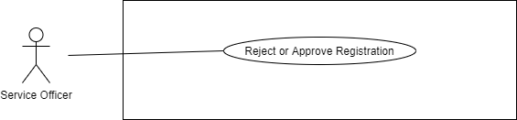

**Figure 19: <Service officer> Approve/ reject registrations use case**

|  |  |  |  |
| --- | --- | --- | --- |
| **USE CASE- APT_3_6** | | | |
| **Use Case No.** | APT_3_6 | **Use Case Version** | 2 |
| **Use Case Name** | Approve or reject registration | | |
| **Author** | Nguyễn Trần Hiển | | |
| **Date** | 12/2/2020 | **Priority** | High |
| **Actor:**   * Service officer   **Summary:**   * This use case allows admin to find approve or reject registration   **Goal:**   * Service officer can approve or reject registration   **Triggers:**   * Service officer sends request approve or reject registration to the system   **Preconditions:**   * User’s identity has been authenticated * Member has request registration   **Post conditions:**   * Success: User’s identity has been authenticated * Fail: System shows error messages.   **Main Success Scenario:**   |  |  |  | | --- | --- | --- | | **Step** | **Actor Action** | **System Response** | | 1 | Member clicks a “Approve” on a registration from Registrations page on APT Web Application. | System shows a confirmation dialog.. | | 2 | Member confirms by filling the reason and clicking “Yes” on the dialog.] | System updates the status of the registration and saves it to database.  System updates the status of the registration and saves it to database. |   **Alternative Scenario:**   |  |  |  | | --- | --- | --- | | **Step** | **Actor Action** | **System Response** | | 1 | Admin/Service officer clicks a “Reject” on a registration from Registrations page on APT Web Application | System shows a confirmation dialog.. | | 2 | Member confirms by filling the reason and clicking “Yes” on the dialog.] | System updates the status of the registration and saves it to database.  System updates the status of the registration and saves it to database. |   **Exceptions:**   |  |  |  | | --- | --- | --- | | **No** | **Cause** | **System Response** | | 1 | System encounters errors while authenticating guest user. | System shows error message for guest System will then show a toast which tells guest user that they need to authenticate again. | | 2 | System encounters errors while fetching registrations from database. | System will then show a toast which tells user the short description of error, and then requires user to refresh the page. |   **Relationships:** N/A  **Business Rules:**  Refer to User Story 03 | | | |

**Table 22: <Service officer> Approve/Reject Registration**

#### 2.3.3.7 <Service Officer> Get Event Tracking Information

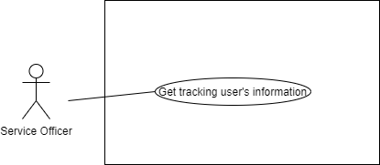

**Figure 21: <Service officer> Get event tracking information use case**

|  |  |  |  |
| --- | --- | --- | --- |
| **USE CASE- APT_3_7** | | | |
| **Use Case No.** | APT_3_7 | **Use Case Version** | 2 |
| **Use Case Name** | View Event Tracking Information | | |
| **Author** |  | | |
| **Date** | 12/2/2020 | **Priority** | High |
| **Actor:**   * Service officer   **Summary:**   * This use case allows member to remove their tracking route.   **Goal:**   * Member can remove the route in their tracking route list when they don’t want to store it anymore.   **Triggers:**   * Member sends delete private route command   **Preconditions:**   * User’s identity has been authenticated * User’s identity has been authenticated   **Post conditions:**   * Success: System deleted route successfully from local storage * Fail: System shows error message   **Main Success Scenario:**   |  |  |  | | --- | --- | --- | | **Step** | **Actor Action** | **System Response** | | 1 | Admin/Service officer clicks “Event tracking” on an event on APT Web Application. | System redirects admin/Service officer to the Event Tracking page for the selected event.  System lists out event tracking entries. | | 2 | Admin/Service officer can search for tracking by student name/email, by time range, by location. | [Optional] Data on the tracking page will automatically refreshed after 5 minutes. |   **Alternative Scenario:** N/A  **Exceptions:**   |  |  |  | | --- | --- | --- | | **No** | **Cause** | **System Response** | | 1 | System encounters errors while authenticating guest user. | System will then show a toast which tells guest user that they need to authenticate again. | | 1 | System encounters errors while fetching tracking information from database. | System will then show a toast which tells user the short description of error, and then requires user to refresh the page. |   **Relationships:** N/A  **Business Rules:**  Refer to User Story 05 | | | |

**Table 23: <Service officer> Get Event Tracking Information**

#### 2.3.3.8 <Service Officer> Create Event

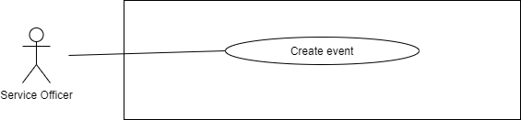

**Figure 23: <Service Officer> Create event use case**

|  |  |  |  |
| --- | --- | --- | --- |
| **USE CASE –APT_4_1** | | | |
| **Use Case No.** | APT_4_1 | **Use Case Version** | 2 |
| **Use Case Name** | Create event | | |
| **Author** | Nguyễn Trần Hiển | | |
| **Date** | 12/2/2020 | **Priority** | Medium |
| **Actor:**   * Service Officer   **Summary:**   * This use case allows admin to create event   **Goal:**   * Service officer can view distance, detailed instructions step by step to reach the destination.   **Triggers:**   * Service officer sends get detail route information command   **Preconditions:**   * User’s identity has been authenticated.   **Post conditions:**   * Success: System redirects Admin to Create Event page. * Fail: System shows error messages.   **Main Success Scenario:**   |  |  |  | | --- | --- | --- | | **Step** | **Actor Action** | **System Response** | | 1 | Service officer clicks “Create Event” | System redirects Admin to Create Event page. | |  | Service officer fills all the required fields and clicks “Create” | System saves event into database.  System shows a toast which tells Admin that the event has been created successfully.  System shows a toast which tells Admin that the event has been created successfully. |   **Alternative Scenario:** N/A  **Exceptions:**   |  |  |  | | --- | --- | --- | | **No** | **Cause** | **System Response** | | 1 | System encounters errors while authenticating guest user. | System will then show a toast which tells guest user that they need to authenticate again. | | 2 | System encounters errors while saving events to database. | System will then show a toast which tells user the short description of error, and then requires user to repeat the action |   **Relationships:**   * N/A   **Business Rules:**  Refer to User Story 01 | | | |

**Table 24: <Service officer> Create Event**

#### 2.3.3.9 <Service Officer> Assign Event

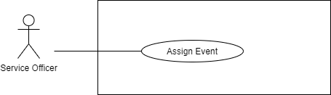

**Figure 23: <Service Officer> Assign event use case**

|  |  |  |  |
| --- | --- | --- | --- |
| **USE CASE- APT_4_2** | | | |
| **Use Case No.** | APT_4_2 | **Use Case Version** | 2 |
| **Use Case Name** | Assign event | | |
| **Author** |  | | |
| **Date** | 12/2/2020 | **Priority** | High |
| **Actor:**   * Service officer   **Summary:**   * This use case allows service officer to assign right to manage event for Service officer.   **Goal:**   * Service officer can assign any event for another service officer   **Triggers:**   * Admin sends assign event command   **Preconditions:**   * User’s identity has been authenticated * Event has created already   **Post conditions:**   * Success: Student office can manage event * Fail: System shows error message   **Main Success Scenario:**   |  |  |  | | --- | --- | --- | | **Step** | **Actor Action** | **System Response** | | 1 | Service officer clicks edit on an event on APT Web Application. | System redirects service officer to the page for the selected student officer. | | 2 | Admin can select and confirm | System change manager of the event |   **Alternative Scenario:** N/A  **Exceptions:**   |  |  |  | | --- | --- | --- | | **No** | **Cause** | **System Response** | | 1 | System encounters errors while authenticating guest user. | System will then show a toast which tells guest user that they need to authenticate again. | | 1 | System encounters errors while fetching tracking information from database. | System will then show a toast which tells user the short description of error, and then requires user to refresh the page. |   **Relationships:** N/A  **Business Rules:**  Refer to User Story 05 | | | |

**Table 24: <Service officer> Assign Event**

#### 2.3.3.10 <Service Officer> Delete Event

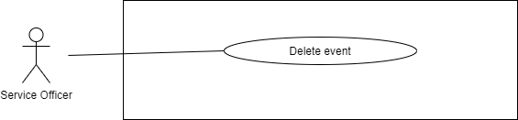

**Figure 16: <Service officer> Edit event use case**

|  |  |  |  |
| --- | --- | --- | --- |
| **USE CASE – APT_3_3** | | | |
| **Use Case No.** | APT_3_3 | **Use Case Version** | 2 |
| **Use Case Name** | Delete event | | |
| **Author** |  | | |
| **Date** | 12/2/2020 | **Priority** | Medium |
| **Actor:**   * Service officer   **Summary:**   * This use case allows service officer to delete event   **Goal:**   * Service officer can delete event   **Triggers:**   * Service officer sends delete event command   **Preconditions:**   * User’s identity has been authenticated   **Post conditions:**   * Success: System redirects SO to the event detail page which shows details for the selected event.   **Main Success Scenario:**   |  |  |  | | --- | --- | --- | | **Step** | **Actor Action** | **System Response** | | 1 | service officer clicks an event from home page on APT Web Application | System redirects admin/Service officer to the event detail page which shows details for the selected event. | | 2 | service officer delete the event | System shows a confirmation dialog | | 3 | Admin/service officer confirms by clicking “yes”. | System remove the event from database.  System shows the information dialog which tells admin/Service officer that the event has been saved successfully. |   **Alternative Scenario:** N/A  **Exceptions:**   |  |  |  | | --- | --- | --- | | **No** | **Cause** | **System Response** | | 1 | System encounters errors while authenticating guest user. | System will then show a toast which tells guest user that they need to authenticate again. | | 2 | System encounters errors while saving events to database. | System will then show a toast which tells user the short description of error, and then requires user to retry. |   **Relationships:**   * Extend from use case: Create event   **Business Rules:**   * Refer to User Story 01 * User can only remove event have status pending | | | |

**Table 19: <Service officer> Remove Event**

#### 2.3.4 <Admin> Overview user case

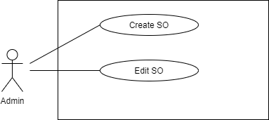

**Figure 22: <Admin> Overview use case**

#### 2.3.4.1 <Admin> Create Service Officer

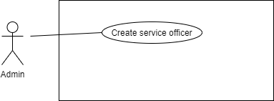

**Figure 24: <Admin> Create service officer**

|  |  |  |  |
| --- | --- | --- | --- |
| **USE CASE- APT_4_2** | | | |
| **Use Case No.** | APT_4_2 | **Use Case Version** | 2 |
| **Use Case Name** | Create service officer | | |
| **Author** |  | | |
| **Date** | 12/2/2020 | **Priority** | High |
| **Actor:**   * Admin   **Summary:**   * This use case allows admin to create service officer.   **Goal:**   * Admin can create new account service officer   **Triggers:**   * Admin sends create services officer command   **Preconditions:**   * User’s identity has been authenticated * Event has created already   **Post conditions:**   * Success: Service officer account is created * Fail: System shows error message   **Main Success Scenario:**   |  |  |  | | --- | --- | --- | | **Step** | **Actor Action** | **System Response** | | 1 | Admin clicks “create” service officer page on APT Web Application. | System redirects admin to the page create new services officer. | | 2 | Admin input information | System create a an account for service officer |   **Alternative Scenario:** N/A  **Exceptions:**   |  |  |  | | --- | --- | --- | | **No** | **Cause** | **System Response** | | 1 | System encounters errors while authenticating guest user. | System will then show a toast which tells guest user that they need to authenticate again. | | 1 | System encounters errors while fetching tracking information from database. | System will then show a toast which tells user the short description of error, and then requires user to refresh the page. |   **Relationships:** N/A  **Business Rules:**  Refer to User Story 05 | | | |

**Table 25: <Admin> Create Service Officer**

#### 2.3.4.2 <Admin> Edit Service Officer

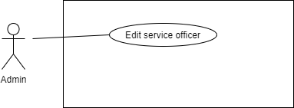

**Figure 24: <Admin> Edit Service Officer**

|  |  |  |  |
| --- | --- | --- | --- |
| **USE CASE- APT_4_2** | | | |
| **Use Case No.** | APT_4_2 | **Use Case Version** | 2 |
| **Use Case Name** | Edit service officer | | |
| **Author** |  | | |
| **Date** | 12/2/2020 | **Priority** | High |
| **Actor:**   * Admin   **Summary:**   * This use case allows admin to edit account of service officer   **Goal:**   * Admin can edit any account service officer   **Triggers:**   * Admin sends edit command   **Preconditions:**   * User’s identity has been authenticated * Event has created already   **Post conditions:**   * Success: Student office can manage event * Fail: System shows error message   **Main Success Scenario:**   |  |  |  | | --- | --- | --- | | **Step** | **Actor Action** | **System Response** | | 1 | Admin clicks edit on service officer account on APT Web Application. | System redirects admin to the page for the selected services officer account. | | 2 | Admin can input update information and confirm | System change account service officer information |   **Alternative Scenario:** N/A  **Exceptions:**   |  |  |  | | --- | --- | --- | | **No** | **Cause** | **System Response** | | 1 | System encounters errors while authenticating guest user. | System will then show a toast which tells guest user that they need to authenticate again. | | 1 | System encounters errors while fetching tracking information from database. | System will then show a toast which tells user the short description of error, and then requires user to refresh the page. |   **Relationships:** N/A  **Business Rules:**  Refer to User Story 05 | | | |

**Table 25: <Admin> Edit Service Officer**

#### 2.3.5 <System> Overview Use Case

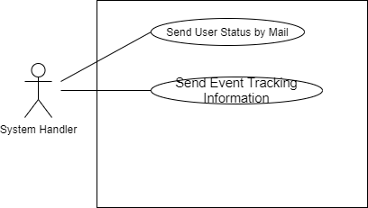

**Figure 25: <System>overview use case**

#### 2.3.5.1 <System> Send Event Tracking Information

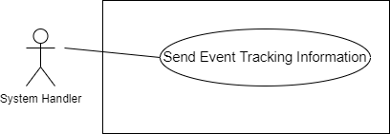

**Figure 26: <System> send event tracking information use case**

|  |  |  |  |
| --- | --- | --- | --- |
| **USE CASE - APT_5_1** | | | |
| **Use Case No.** | APT_5_1 | **Use Case Version** | 2 |
| **Use Case Name** | Send tracking information | | |
| **Author** | Nguyễn Trần Hiển | | |
| **Date** | 2/10/2020 | **Priority** | Low |
| **Actor:**   * System   **Summary:**   * This use case allows system send tracking information to admin   **Goal:**   * Admin can recieve tracking information each 5 minutes   **Triggers:**   * System sends event tracking information command   **Preconditions:**   * The event is started. * Student has checked-in the event. * Student turn on location   **Post Conditions:**   * Success: System requests student for permissions to access device location * Fail: System shows error message   **Main Success Scenario:**   |  |  |  | | --- | --- | --- | | **Step** | **Actor Action** | **System Response** | | 1 | System requests student for permissions to access device location | System requests student for permissions to access device location | |  |  |  |   **Alternative Scenario:** N/A  **Exceptions:**   |  |  |  | | --- | --- | --- | | **No** | **Cause** | **System Response** | | 1 | System retrieves an empty list of account | System shows message “Not found any user account” for admin | | 2 | Get account process encountered an internal error | System shows error message for admin |   **Relationships:** N/A  **Business Rules:**   * Refer to User Story 05 | | | |

**Table 26: <System> Send Event Tracking Information**

#### 2.3.5.2 <System> Send email notification

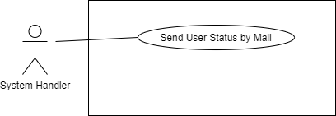

**Figure 27: <System> send email notification use case**

|  |  |  |  |
| --- | --- | --- | --- |
| **USE CASE- APT_5_2** | | | |
| **Use Case No.** | APT_5_2 | **Use Case Version** | 2 |
| **Use Case Name** | Send email notification | | |
| **Author** |  | | |
| **Date** | 2/10/2020 | **Priority** | Low |
| **Actor:**   * System   **Summary:**   * This use case allows System send notification to the member   **Goal:**   * Admin can send email notification to the member.   **Triggers:**   * System send notification by email command   **Preconditions:**   * Email is valid.   **Post Conditions:**   * Success: The user recieves email notification * Fail: System shows error messages   **Main Success Scenario:**   |  |  |  | | --- | --- | --- | | **Step** | **Actor Action** | **System Response** | | 1 | System handler send email notification to the user | System detect email |   **Alternative Scenario:**  **N/A**  **Exceptions:  N/A**  **Relationships:** N/A  **Business Rules:**   * Refer to User Story 05 | | | |

**Table 27: <System> Send email notification**

#### 2.3.6 <Authorized User> Overview Use Case

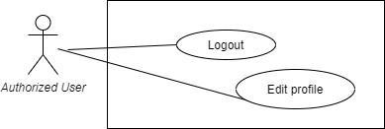

**Figure 28: <Authorized User> Logout use case**

#### 2.3.6.1 < Authorized User > Logout

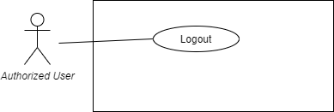

**Figure 29: <Authorized User> Logout use case**

|  |  |  |  |
| --- | --- | --- | --- |
| **USE CASE- APT_5__1** | | | |
| **Use Case No.** | APT_5_1 | **Use Case Version** | 2 |
| **Use Case Name** | Logout | | |
| **Author** |  | | |
| **Date** | 2/10/2020 | **Priority** | High |
| **Actor:**   * Authorized User   **Summary:**   * This use case allows authorized user to logout   **Goal:**   * Authorized user can exit from system   **Triggers:**   * Authorized user sends logout command   **Preconditions:**   * User account has been created. * User account has logged in to the system with specific role   **Post Conditions:**   * Success: System redirects to login view * Fail: System shows error message   **Main Success Scenario:**   |  |  |  | | --- | --- | --- | | **Step** | **Actor Action** | **System Response** | | 1 | Authorized user sends logout command | System redirects to the login view |   **Alternative Scenario:** N/A  **Exceptions:**   |  |  |  | | --- | --- | --- | | **No** | **Cause** | **System Response** | | 1 | Logout process encountered an internal error | System shows error message for authorized user |   **Relationships:** N/A  **Business Rules:**   * Authorized user exit completely from the system * The system must clear token and session of user | | | |

**Table 28: <Authorized User> Log out user case**

#### 2.3.6.2 < Authorized User > Edit profle

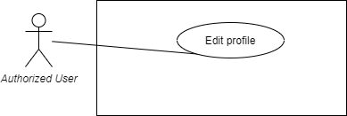

**Figure 29: <Authorized User> Edit profile use case**

|  |  |  |  |
| --- | --- | --- | --- |
| **USE CASE- APT_5__1** | | | |
| **Use Case No.** | APT_5_1 | **Use Case Version** | 2 |
| **Use Case Name** | Logout | | |
| **Author** |  | | |
| **Date** | 2/10/2020 | **Priority** | High |
| **Actor:**   * Authorized User   **Summary:**   * This use case allows authorized user to edit profile   **Goal:**   * Authorized user can update information   **Triggers:**   * Authorized user sends update profile command   **Preconditions:**   * User account has been created. * User account has logged in to the system with specific role   **Post Conditions:**   * Success: System redirects to login view * Fail: System shows error message   **Main Success Scenario:**   |  |  |  | | --- | --- | --- | | **Step** | **Actor Action** | **System Response** | | 1 | Authorized user click confirm update profile | System redirects to the home page |   **Alternative Scenario:** N/A  **Exceptions:**   |  |  |  | | --- | --- | --- | | **No** | **Cause** | **System Response** | | 1 | Logout process encountered an internal error | System shows error message for authorized user |   **Relationships:** N/A  **Business Rules:**   * The profle information will be update | | | |

**Table 28: <Authorized User> Update profile user case**

### 3.Software System Attribute

#### 3.1 Usability

- Easy and simple to start: user can use 90% of application’s features in the first time (about 15 minutes) and 100% for the next time

- Basic designs for APT system are user centric, and user intuitive. Anyone who’s using a smartphone can easily get used to the system within 10 minutes.

- The similar thing applies to the web application (will be familiar with anyone who are familiar with LMS systems).

- Important, recently visited locations are displayed by a highlighted font than other elements

- 90% users feel comfortable when using our application

#### 3.2 Reliability

- APT system has to be available for almost 99.99% because this is time-centric and student tracking data will not be fully reflected if we have an error while system tracks students.

- Mean Time Between Failures: 2 months.

- Mean Time To Repair: 2 hours.

- Bugs or Defect Rate: N/A

#### 3.3 Availability

- The system must be available at any time 24/7

- When system has errors, it can be restarted in 15 minutes

#### 3.4 Security

- System authorizes role clearly, each role has specified permission to interact with system

- APT system is based on GPS tracking technique, and don’t interfere with other functions. No extra actions required from users (mobile apps), thus will not lead to any safety issues while system operates

- Only admin role has full permission to the system

#### 3.5 Maintainability

- The system is divided into separate modules for easy maintain

#### 3.6 Portability

- Website can be used with any platform, connected by the internet

- Web admin can be run on all popular browsers, including Chromium based browsers (last 2 versions), Mozilla Firefox (last 2 versions) and, Apple Safari (last 2 versions)

#### 3.7 Performance

- Fast, efficient manipulations: service work with maximum 5000 request per seconds.

### 4. Conceptual Diagram

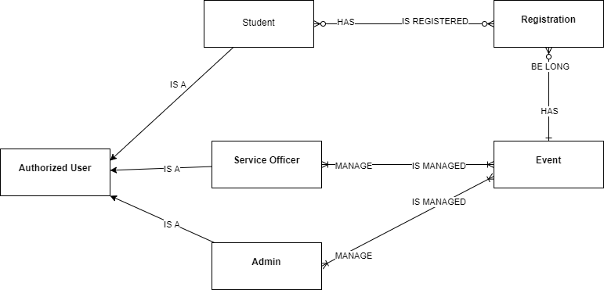

Figure 30: Conceptual Diagram

**Data Dictionary**

|  |  |
| --- | --- |
| **Entity Data dictionary: describe all content of all entities** | |
| **Entity Name** | **Description** |
| Authorized User | Abstract entity describes a user in system |
| Admin | Contain the admin information |
| Student | Contain the student information |
| Service officer | Contain the Service officer information |
| Registration | Contain the registration information |
| Event | Contain the event information |

**Table 49: Conceptual Diagram Data Dictionary**

# **D. Report No. 4 Software Design Description**

## 1. Design Overview

* This document describes the technical and user interface design of the APT System. It includes the architectural design, the detailed design of common functions and business functions and the design of database models.
* The architectural design describes the overall architecture of the system and the architecture of each main component and subsystem.
* The detailed design describes static and dynamic structure for each component and functions. It includes class diagrams, class explanations and sequence diagrams for each use case.
* The database design describes the relationships between entities and details of each entity.
* Document overview:
* Section 2: gives an overall description of the system architecture design.
* Section 3: gives component diagrams that describe the connection and integration of the system.
* Section 4: gives the detailed design description which includes class diagram, class explanation, and sequence diagram to details the application functions.
* Section 5: describe screens design.
* Section 6: describe a fully attributed ERD.
* Section 7: describe algorithms

## 2. System architecture design

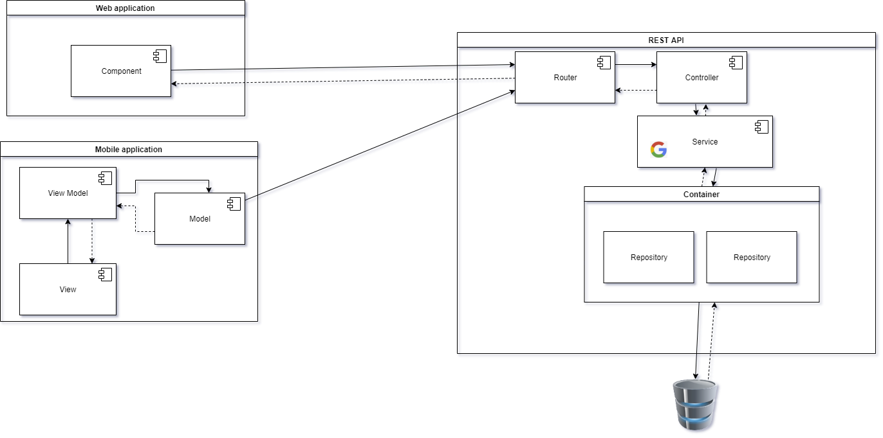

**The system is developed under N-tier architecture style. We choose this architecture because of following advantages:**

* We can add more components without rewriting the entire application or designing again.
* By separating into independent tiers, the system is easy to maintain without affecting each other.
* N-tier helps projects to divide into small modules easily so we can assign to team members easier.

**In mobile application, we use mvvm architecture because of following advantages:**

* The project is easier to maintain
* This architecture provides clearer UI and application logic
* We can add new features easily

## 3. Component diagram



### 3.1 Web application

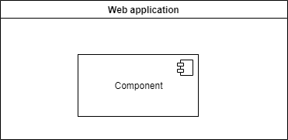

|  |  |
| --- | --- |
| **COMPONENT DICTIONARY: DESCRIBES COMPONENTS** | |
| **Web application** |  |
| **Component** | Features for Admin |

### 3.2 C sharp server

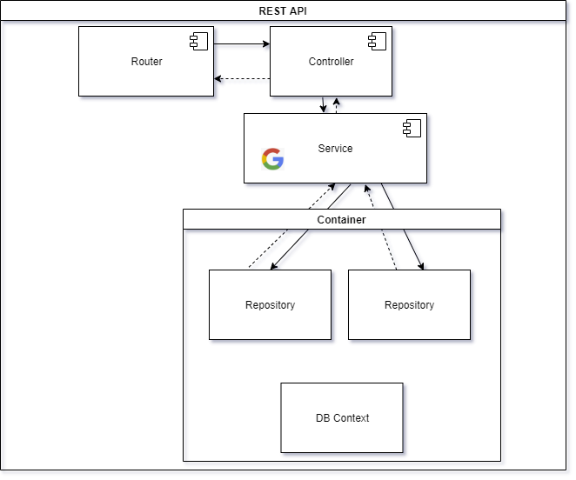

|  |  |
| --- | --- |
| **COMPONENT DICTIONARY: DESCRIBES COMPONENTS** | |
| **C# server** |  |
| **Service** | Provide service for controller |
| **Route** | Route finding processing |
| **Repository** | DTO mapping database |
| **DB Context** | Excute command |

### 3.3 Mobile

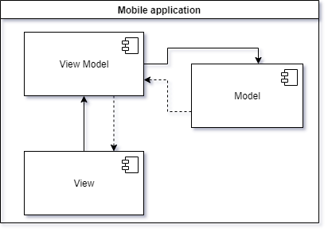

|  |  |
| --- | --- |
| **COMPONENT DICTIONARY: DESCRIBES COMPONENTS** | |
| **Mobile application** |  |
| **View** | Feature of student |
| **View Model** | business processing |
| **Model** | Business rules |

## 4. Detailed description

### 4.1 Class diagram

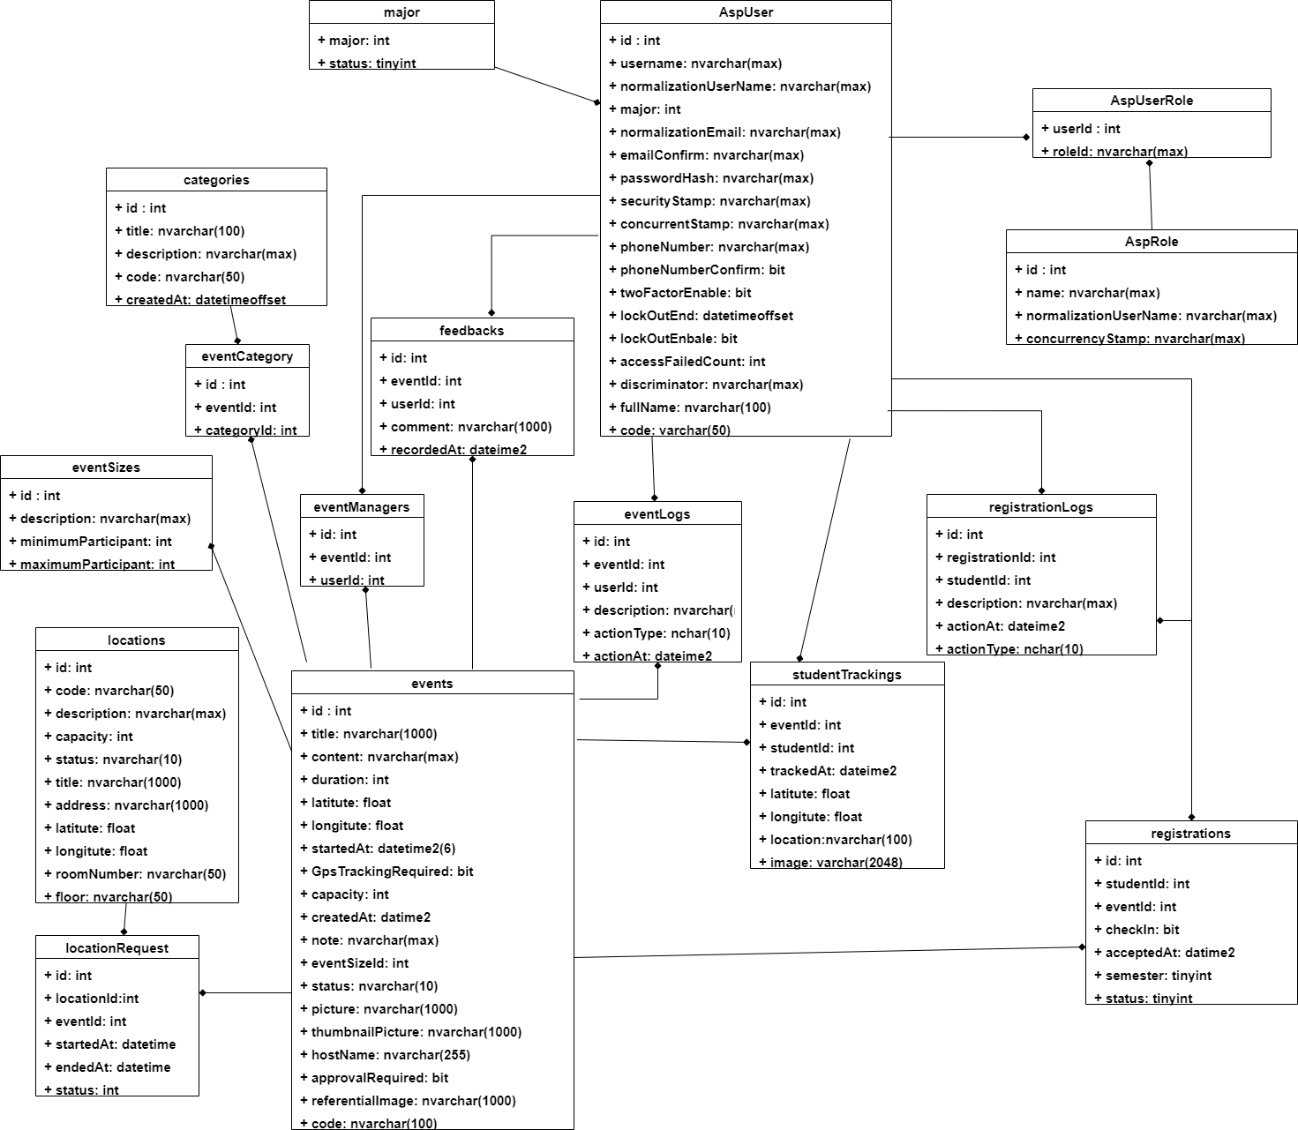

### 4.2 Class diagram explanation

|  |  |  |
| --- | --- | --- |
| **CLASS DICTIONARY: DESCRIBE CLASS** | | |
| **Class Name** | **Mapping column with Conceptual diagram** | **Description** |
| **AspUser** | Authorized User | Contains the information of user |
| **AspUserRole** | N/A | Contains the information of what is the role of user |
| **AspRole** | N/A | Not exist in Conceptual diagram but needs to contain role of user |
| **RegistrationLogs** | N/A | Not exist in Conceptual diagram but need to contain registration of user |
| **Registrations** | Registration | Contain the information of registration |
| **StudentTrackings** | N/A | Not exist in Conceptual diagram but need to contain information of user in event |
| **EventLogs** | N/A | Not exist in Conceptual diagram but need to contain history of user join in event |
| **Major** | N/A | Not exist in Conceptual diagram but need to contain information of major in FPT university |
| **Feedbacks** | N/A | Not exist in Conceptual diagram but need to contain feedback of user to event |
| **EventManagers** | N/A | Not exist in Conceptual diagram but need to contain information of who is managed event |
| **Events** | Event | Contain the information of event |
| **LocationRequest** | N/A | Not exist in Conceptual diagram but need to contain information of where is hold |
| **Locations** | N/A | Not exist in Conceptual diagram but need to contain information of location |
| **EventSizes** | N/A | Not exist in Conceptual diagram but need to contain information kind of event size |
| **EventCategory** | N/A | Not exist in Conceptual diagram but need to contain information what is the event size |
| **Categories** | N/A | Not exist in Conceptual diagram but need to contain information kind of event category |

#### 4.2.1 AspUser

|  |  |  |  |
| --- | --- | --- | --- |
| **Attribute** | **Type** | **Visibility** | **Description** |
| Id | Int | Private | Unique identifier of an user |
| Username | String | Private | User’s Name |
| NormalizedUserName | String | Private | User’s normalized user name |
| Email | String | Private | User’s email |
| NormalizedEmail | String | Private | User’s normalized email |
| EmailConfirmed | Boolearn | Private | User’s email status confirm |
| PasswordHash | String | Private | User’s password |
| SecurityStamp | String | Private | User’s security stamp |
| ConcurrencyStamp | String | Private | User’ currency stamp |
| PhoneNumber | String | Private | User’s phone number |
| PhoneNumberConfirmed | Boolearn | Private | User’s phone number status confirm |
| TwoFactorEnabled | Boolearn | Private | User’s factory status |
| LockoutEnd | DateTime | Private | User’ lockout date |
| LockoutEnabled | Boolearn | Private | User’s lockout status |
| AccessFailedCount | Int | Private | User’s count access failed |
| Discriminator | String | Private | User’s discriminator |
| Major | String | Private | User’s major |
| Code | String | Private | User’s code |
| FullName | String | Private | User’s fullname |

|  |  |  |  |
| --- | --- | --- | --- |
| **Method** | **Return type** | **Visibility** | **Description** |
| Getter | Data type | Public | Get attribute value |
| Setter | Void | Public | Set value of attribute |

#### 4.2.2 AspUserRole

|  |  |  |  |
| --- | --- | --- | --- |
| **Attribute** | **Type** | **Visibility** | **Description** |
| RoleId | Int | Private | Role’s identifier for an account |
| UserId | Int | Private | User’s identifier for an account |

|  |  |  |  |
| --- | --- | --- | --- |
| **Method** | **Return type** | **Visibility** | **Description** |
| Getter | Data type | Public | Get attribute value |
| Setter | Void | Public | Set value of attribute |

#### 4.2.3 AspRole

|  |  |  |  |
| --- | --- | --- | --- |
| **Attribute** | **Type** | **Visibility** | **Description** |
| Id | Int | Private | Unique identifier of a role |
| Name | String | Private | Role’s name |
| NormalizedName | String | Private | Role’s normalized name |
| ConcurrencyStamp | String | Private | Role’s concurrency stamp |

|  |  |  |  |
| --- | --- | --- | --- |
| **Method** | **Return type** | **Visibility** | **Description** |
| Getter | Data type | Public | Get attribute value |
| Setter | Void | Public | Set value of attribute |

#### 4.2.4 RegistrationLogs

|  |  |  |  |
| --- | --- | --- | --- |
| **Attribute** | **Type** | **Visibility** | **Description** |
| Id | Int | Private | Unique identifier of registration logs |
| RegistrationId | Int | Private | Shortest_Route’s start node |
| UserId | Int | Private | User’s identifier for an registration logs |
| ActionAt | DateTime | Private | Registration’s date |
| ActionType | String | Private | Registration’s action type |
| Description | String | Private | Registration’s description |

|  |  |  |  |
| --- | --- | --- | --- |
| **Method** | **Return type** | **Visibility** | **Description** |
| Getter | Data type | Public | Get attribute value |
| Setter | Void | Public | Set value of attribute |

#### 4.2.5 Registrations

|  |  |  |  |
| --- | --- | --- | --- |
| **Attribute** | **Type** | **Visibility** | **Description** |
| Id | Int | Private | Unique identifier of registration |
| EventId | Int | Private | Event’s identifier for an registration |
| UserId | Int | Private | User’s identifier for an registration |
| CreatedAt | DateTime | Private | Registration’s create date |
| CheckedIn | Boolearn | Private | Registration’s check in date |
| Semester | Int | Private | Registration’s semester |
| Status | Int | Private | Registration’s status |

|  |  |  |  |
| --- | --- | --- | --- |
| **Method** | **Redirect Type** | **Visibility** | **Description** |
| Getter | Data type | Public | Get attribute value |
| Setter | Void | Public | Set value of attribute |

#### 4.2.6 StudentTrackings

|  |  |  |  |
| --- | --- | --- | --- |
| **Attribute** | **Type** | **Visibility** | **Description** |
| Id | Int | Private | Unique identifier of student tracking |
| EventId | Int | Private | Event’s identifier for student tracking |
| StudentId | Int | Private | User’s identifier for student tracking |
| TrackedAt | Date | Private | Student tracking’s tracked date |
| Latitude | Float | Private | Student tracking’s latitude |
| Longitude | Float | Private | Student tracking’s longtitude |
| Location | String | Private | Student tracking’s location |
| Image | String | Private | Student tracking’s image |

**Table 65: <Class Diagram Attribute> Notification**

|  |  |  |  |
| --- | --- | --- | --- |
| **Method** | **Return type** | **Visibility** | **Description** |
| Getter | Data type | Public | Get attribute value |
| Setter | Void | Public | Set value of attribute |

#### 4.2.7 EventLogs

|  |  |  |  |
| --- | --- | --- | --- |
| **Attribute** | **Type** | **Visibility** | **Description** |
| Id | Int | Private | Unique identifier of event logs |
| EventId | String | Private | Formula’s name |
| UserId | Int | Private | User’s identifier for an event logs |
| ActionAt | Int | Private | Event log’s date |
| ActionType | DateTime | Private | Event log’s action type |
| Description | String | Private | Event log’s description |

|  |  |  |  |
| --- | --- | --- | --- |
| **Method** | **Return type** | **Visibility** | **Description** |
| Getter | Data type | Public | Get attribute value |
| Setter | Void | Public | Set value of attribute |

#### 4.2.9 Major

|  |  |  |  |
| --- | --- | --- | --- |
| **Attribute** | **Type** | **Visibility** | **Description** |
| Major | String | Private | Unique identifier of major |
| Status | Int | Private | Major’s status |

|  |  |  |  |
| --- | --- | --- | --- |
| **Method** | **Return type** | **Visibility** | **Description** |
| Getter | Data type | Public | Get attribute value |
| Setter | Void | Public | Set value of attribute |

#### 4.2.10 Feedbacks

|  |  |  |  |
| --- | --- | --- | --- |
| **Attribute** | **Type** | **Visibility** | **Description** |
| Id | Int | Private | Unique identifier of feed backs |
| EventId | String | Private | Event’s identifier for feedback |
| UserId | Int | Private | User’s identifier for feedback |
| Comment | String | Private | Feedback’s comment content |
| RecordedAt | DateTime | Private | Feedback’s date |

|  |  |  |  |
| --- | --- | --- | --- |
| **Method** | **Return type** | **Visibility** | **Description** |
| Getter | Data type | Public | Get attribute value |
| Setter | Void | Public | Set value of attribute |

#### 4.2.11 EventManagers

|  |  |  |  |
| --- | --- | --- | --- |
| **Attribute** | **Type** | **Visibility** | **Description** |
| Id | Long | Private | Unique identifier of event’s manager |
| EventId | String | Private | Event’s identifier for event manager |
| UserId | Int | Private | User’s identifier for event manager |

|  |  |  |  |
| --- | --- | --- | --- |
| **Method** | **Return type** | **Visibility** | **Description** |
| Getter | Data type | Public | Get attribute value |
| Setter | Void | Public | Set value of attribute |

#### 4.2.12 Events

|  |  |  |  |
| --- | --- | --- | --- |
| **Attribute** | **Type** | **Visibility** | **Description** |
| Id | Int | Private | Unique identifier of event |
| Title | String | Private | Event’s title |
| Content | String | Private | Event’s content |
| Duration |  |  | Event’s duration |
| Latitude | Float | Private | Student tracking’s latitude |
| Longitude | Float | Private | Student tracking’s longtitude |
| StartedAt | DateTime | Private | Event’s start date |
| GpsTrackingRequired | Boolearn | Private | Event’s gps tracking status |
| Capacity | Int | Private | Event’s maximum participants |
| CreatedAt | DateTime | Private | Event’s create date |
| Note | String | Private | Event’s note |
| EventSizeId | Int | Private | Size of event’s identifier for event |
| Status | String | Private | Event’s status |
| Picture | String | Private | Event’s picture |
| ThumbnailPicture | String | Private | Event’s thumbnail picture |
| HostName | String | Private | Event’s host name |
| ApprovalRequired | Boolearn | Private | Event’s approve status |
| ReferentialImage | String | Private | Event’s referential picture |
| Code | String | Private | Event’s code |

|  |  |  |  |
| --- | --- | --- | --- |
| **Method** | **Return type** | **Visibility** | **Description** |
| Getter | Data type | Public | Get attribute value |
| Setter | Void | Public | Set value of attribute |

#### 4.2.13 LocationRequest

|  |  |  |  |
| --- | --- | --- | --- |
| **Attribute** | **Type** | **Visibility** | **Description** |
| Id | Int | Private | Unique identifier of request location |
| EventId | Int | Private | Event’s identifier for location request |
| LocationId | Int | Private | Location’s identifier for location request |
| StartedAt | DateTime | Private | Event request location start date |
| EndedAt | DateTime | Private | Event request location end date |
| Status | Int | Private | Location request’s status |

|  |  |  |  |
| --- | --- | --- | --- |
| **Method** | **Return type** | **Visibility** | **Description** |
| Getter | Data type | Public | Get attribute value |
| Setter | Void | Public | Set value of attribute |

#### 4.2.14 Locations

|  |  |  |  |
| --- | --- | --- | --- |
| **Attribute** | **Type** | **Visibility** | **Description** |
| Id | Long | Private | Unique identifier of location |
| Code | String | Private | Location’s code |
| Description | String | Private | Location’s description |
| Capacity | Int | Private | Location’s maximum participant |
| Status | String | Private | Location’s status |
| Title | String | Private | Location’s title |
| Address | String | Private | Location’s address |
| RoomNumber | String | Private | Location’s room number |
| Floor | String | Private | Location’s floor |
| Latitude | Float | Private | Location’s latitude |
| Longitude | Float | Private | Location’s longtitude |

|  |  |  |  |
| --- | --- | --- | --- |
| **Method** | **Return type** | **Visibility** | **Description** |
| Getter | Data type | Public | Get attribute value |
| Setter | Void | Public | Set value of attribute |

#### 4.2.15 EventSizes

|  |  |  |  |
| --- | --- | --- | --- |
| **Attribute** | **Type** | **Visibility** | **Description** |
| Id | Long | Private | Unique identifier of event size |
| Description | String | Private | Event size’s description |
| MinimizeParticipant | Int | Private | Event size’s minimum participant |
| MaximumParticipant | Int | Private | Event size’s maximum participant |

|  |  |  |  |
| --- | --- | --- | --- |
| **Method** | **Return type** | **Visibility** | **Description** |
| Getter | Data type | Public | Get attribute value |
| Setter | Void | Public | Set value of attribute |

#### 4.2.16 EventCategory

|  |  |  |  |
| --- | --- | --- | --- |
| **Attribute** | **Type** | **Visibility** | **Description** |
| Id | Int | Private | Unique identifier of event category |
| EventId | Int | Private | Event’s identifier for location request |
| CategoryId | Int | Private | Event category’s identifier for location request |

|  |  |  |  |
| --- | --- | --- | --- |
| **Method** | **Return type** | **Visibility** | **Description** |
| Getter | Data type | Public | Get attribute value |
| Setter | Void | Public | Set value of attribute |

#### 4.2.17 Categories

|  |  |  |  |
| --- | --- | --- | --- |
| **Attribute** | **Type** | **Visibility** | **Description** |
| Id | Int | Private | Unique identifier of categories |
| Code | String | Private | Category’s code |
| Title | String | Private | Category’s title |
| Description | String | Private | Category’s description |
| CreateAt | DateTime | Private | Category’s create date |

|  |  |  |  |
| --- | --- | --- | --- |
| **Method** | **Return type** | **Visibility** | **Description** |
| Getter | Data type | Public | Get attribute value |
| Setter | Void | Public | Set value of attribute |

### 4.3 Interaction Diagram

#### 4.3.1 Check in by image

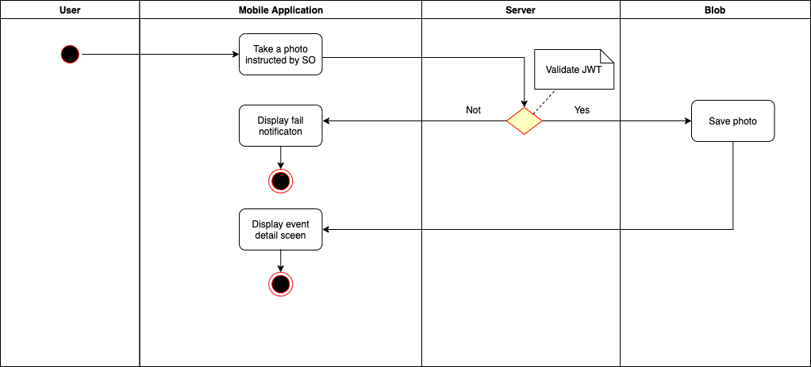

#### 4.3.2 Check in by QR

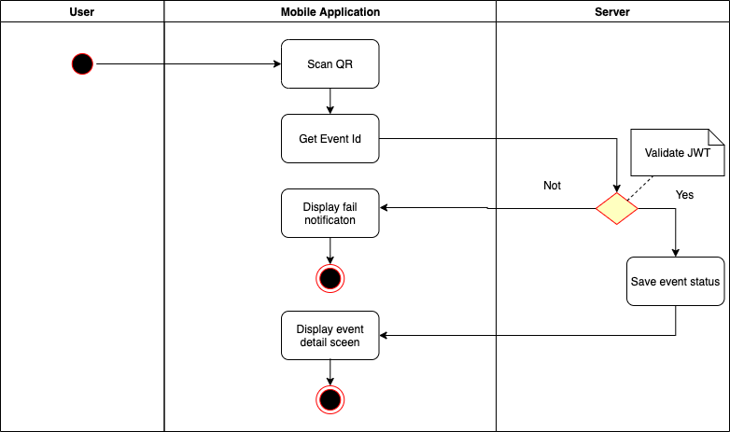

#### 4.3.3 Send feedback

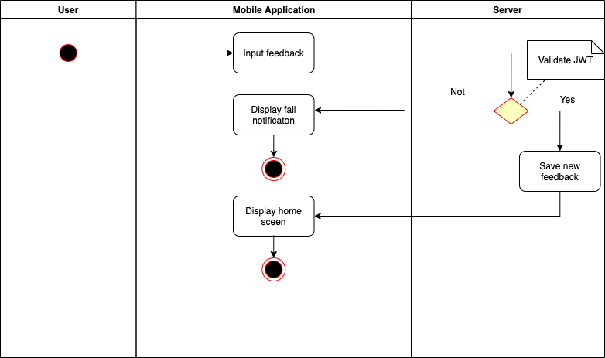

#### 4.3.4 Get event

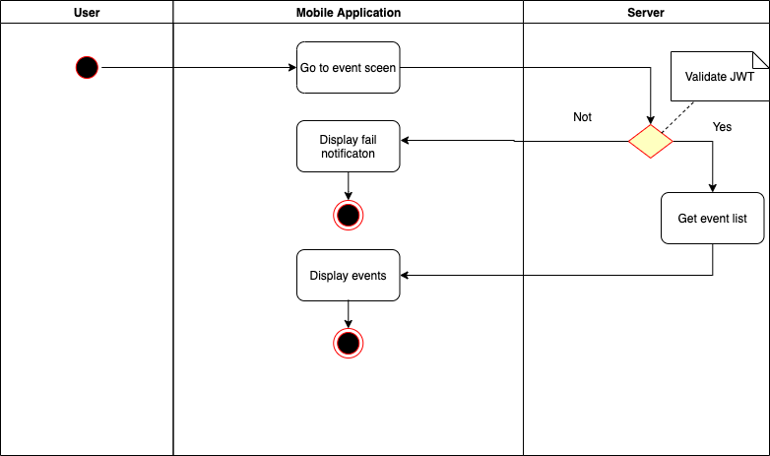

#### 4.3.5 Login

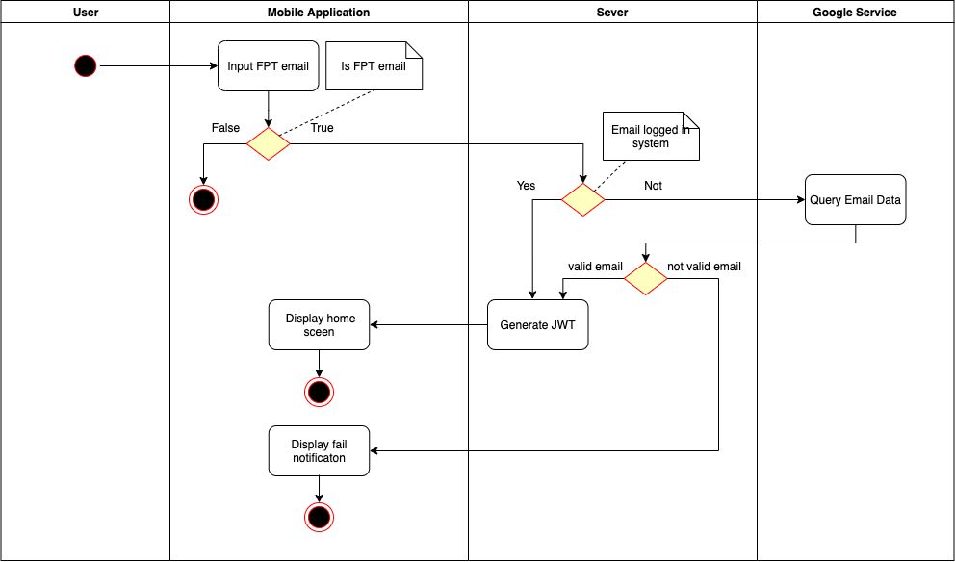

#### 4.3.6 Send event tracking

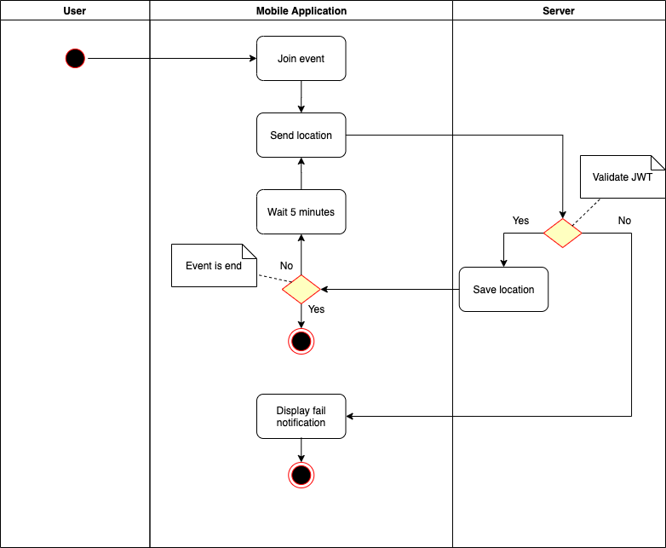

#### 4.3.7 Update information user

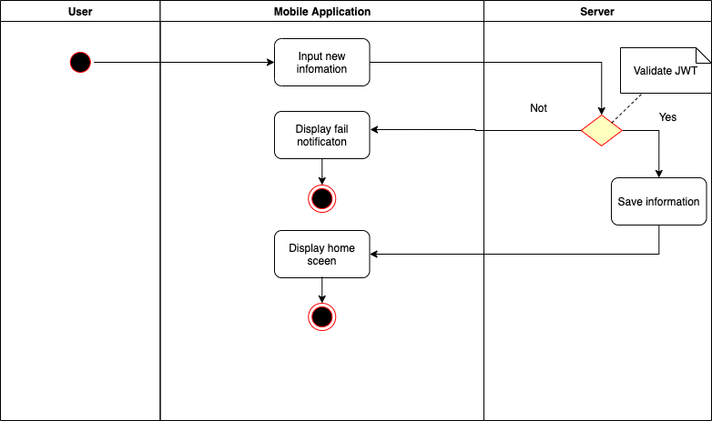

### 4.4 Sequence Diagram

#### 4.4.1 Create event

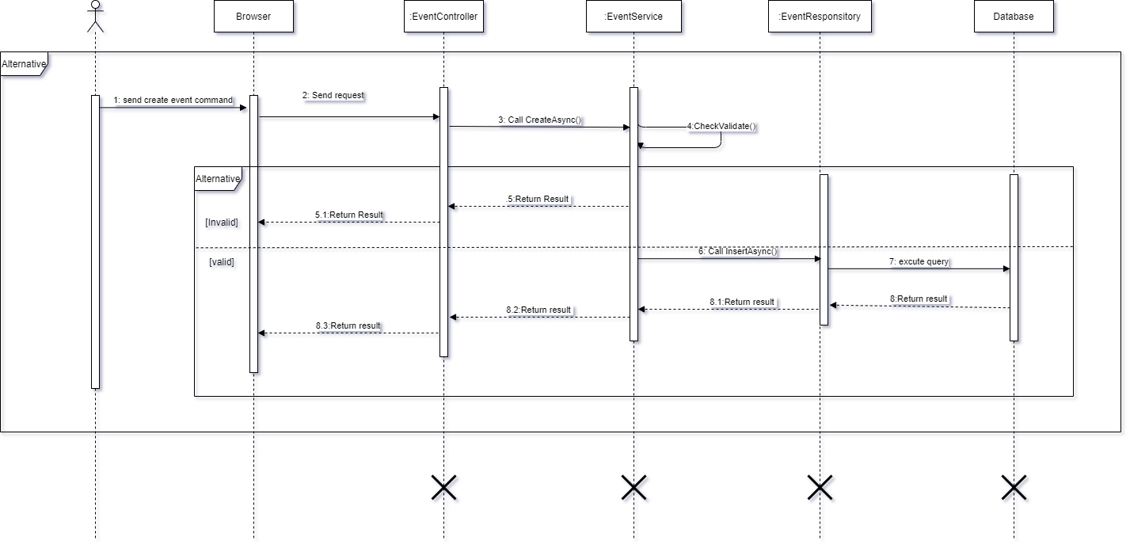

## 5. Interface team tự update phân này

### 5.1 User Interface Design

#### 5.1.1 Login

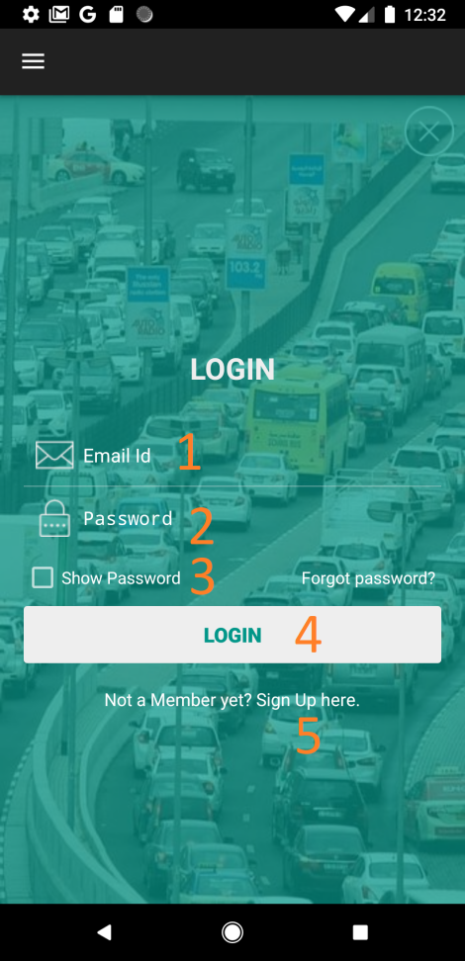

**Figure 88: Login interface**

**Fields**

|  |  |  |  |  |  |  |  |
| --- | --- | --- | --- | --- | --- | --- | --- |
| **No** | **Field Name** | **Description** | **Read only** | **Mandatory** | **Control Type** | **Data Type** | **Length** |
|  |  |  |  |  |  |  |  |
|  |  |  |  |  |  |  |  |

**Buttons/Hyperlinks:**

|  |  |  |  |  |
| --- | --- | --- | --- | --- |
| **No** | **Function** | **Description** | **Validation** | **Outcome** |
|  |  |  |  |  |
|  |  |  |  |  |
|  |  |  |  |  |

#### 5.1.2 Register

**Fields**

|  |  |  |  |  |  |  |  |
| --- | --- | --- | --- | --- | --- | --- | --- |
| **No** | **Field Name** | **Description** | **Read only** | **Mandatory** | **Control Type** | **Data Type** | **Length** |
|  |  |  |  |  |  |  |  |
|  |  |  |  |  |  |  |  |

**Buttons/Hyperlinks:**

|  |  |  |  |  |
| --- | --- | --- | --- | --- |
| **No** | **Function** | **Description** | **Validation** | **Outcome** |
|  |  |  |  |  |
|  |  |  |  |  |
|  |  |  |  |  |

#### 5.1.3 Main screen

#### 

**Figure 71: Main screen interface**

**Fields**

|  |  |  |  |  |  |  |  |
| --- | --- | --- | --- | --- | --- | --- | --- |
| **No** | **Field Name** | **Description** | **Read only** | **Mandatory** | **Control Type** | **Data Type** | **Length** |
| 2 | Search location | Fill address to search | No | Yes | Text | String | N/A |

**Buttons/Hyperlinks:**

|  |  |  |  |  |
| --- | --- | --- | --- | --- |
| **No** | **Function** | **Description** | **Validation** | **Outcome** |
| 1 | Navigation bar | Navigation bar | N/A | Redirect to navigation |
| 3 | Current location | Current location | N/A | Show current location |
| 4 | Find route | Find route from origin and destination | Required | Draw a route from origin to destination |

#### 5.1.4 Guest Navigation bar

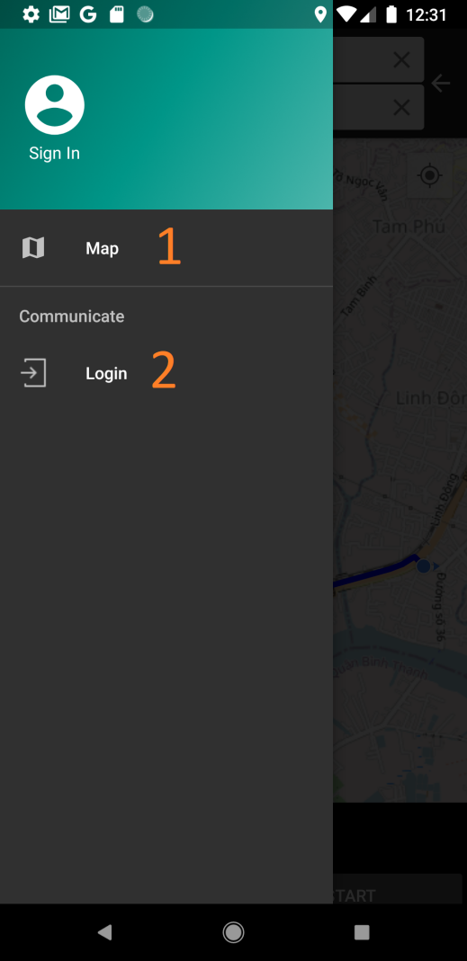

**Figure 72: Guest Navigation bar interface**

**Buttons/Hyperlinks:**

|  |  |  |  |  |
| --- | --- | --- | --- | --- |
| **No** | **Function** | **Description** | **Validation** | **Outcome** |
| 2 | Map | Map | N/A | Redirect to map screen |
| 6 | Login | Login | User didn’t log in to the system | Redirect to login screen |

#### 5.1.5 Main Navigation bar

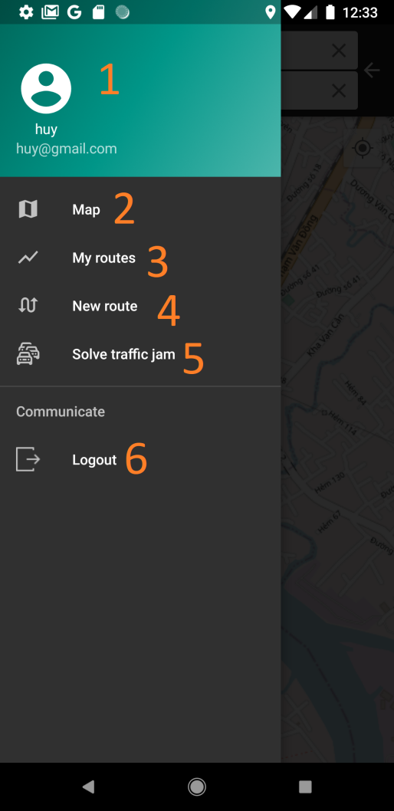

**Fields**

|  |  |  |  |  |  |  |  |
| --- | --- | --- | --- | --- | --- | --- | --- |
| **No** | **Field Name** | **Description** | **Read only** | **Mandatory** | **Control Type** | **Data Type** | **Length** |
| 1 | User information | User information | Yes | Yes | Text | String | N/A |

**Buttons/Hyperlinks:**

|  |  |  |  |  |
| --- | --- | --- | --- | --- |
| **No** | **Function** | **Description** | **Validation** | **Outcome** |
| 2 | Map | Map | N/A | Redirect to map screen |
| 3 | My routes | My routes | User must login with role: Member | Redirect to member’s route screen |
| 4 | New route | New route | User must login with role: Member | Redirect to new route screen |
| 5 | Solve traffic jam | Solve traffic jam | User must login with role: Collaborator | Detect traffic jam on the map |
| 6 | Logout | Logout | User must login to the system | Exit system and back to login screen |

#### 5.1.6 Find location

#### 

**Fields**

|  |  |  |  |  |  |  |  |
| --- | --- | --- | --- | --- | --- | --- | --- |
| **No** | **Field Name** | **Description** | **Read only** | **Mandatory** | **Control Type** | **Data Type** | **Length** |
| 1 | Search | Input location to search | No | Yes | Text | String | N/A |
| 4 | History search | Last 3 search locations | Yes | Yes | Text | String | N/A |

**Buttons/Hyperlinks:**

|  |  |  |  |  |
| --- | --- | --- | --- | --- |
| **No** | **Function** | **Description** | **Validation** | **Outcome** |
| 2 | Current location | Current location | User’s gps is enabled | Show address of current location |
| 3 | Delete | Delete | N/A | Remove user’s input |
| 5 | Back | Back | N/A | Back to map screen |

#### 5.1.7 View location info

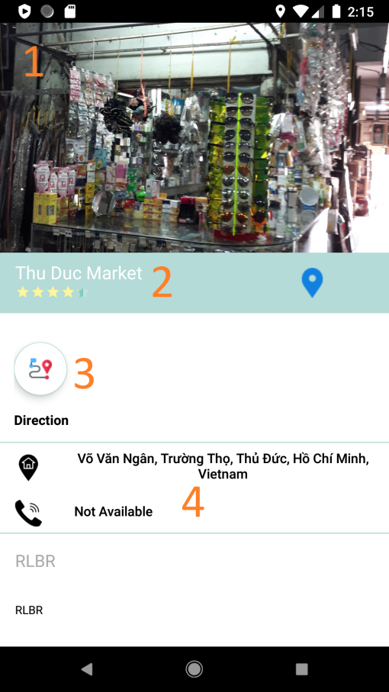

**Figure 75: View location info interface**

**Fields**

|  |  |  |  |  |  |  |  |
| --- | --- | --- | --- | --- | --- | --- | --- |
| **No** | **Field Name** | **Description** | **Read only** | **Mandatory** | **Control Type** | **Data Type** | **Length** |
|  |  |  |  |  |  |  |  |
|  |  |  |  |  |  |  |  |

**Buttons/Hyperlinks:**

|  |  |  |  |  |
| --- | --- | --- | --- | --- |
| **No** | **Function** | **Description** | **Validation** | **Outcome** |
|  |  |  |  |  |
|  |  |  |  |  |
|  |  |  |  |  |

#### 5.1.8 Start tracking route

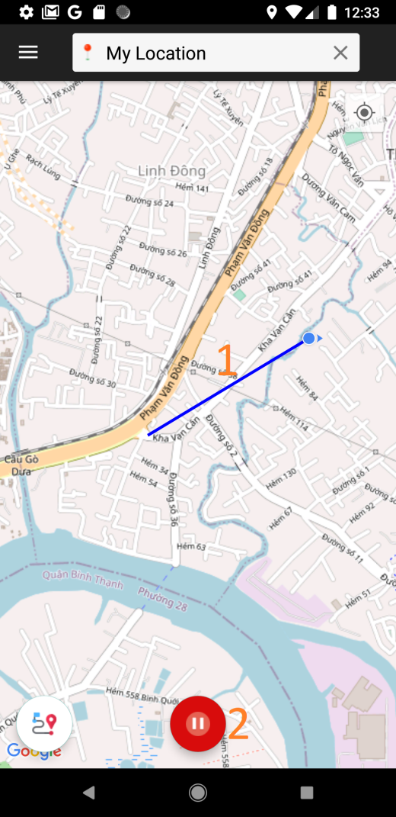

**Figure 76: Start tracking route interface**

**Fields**

|  |  |  |  |  |  |  |  |
| --- | --- | --- | --- | --- | --- | --- | --- |
| **No** | **Field Name** | **Description** | **Read only** | **Mandatory** | **Control Type** | **Data Type** | **Length** |
| 1 | N/A | User’s real-time moving | No | Yes | N/A | Polyline | N/A |

**Buttons/Hyperlinks:**

|  |  |  |  |  |
| --- | --- | --- | --- | --- |
| **No** | **Function** | **Description** | **Validation** | **Outcome** |
| 2 | Stop | Stop record | N/A | Stop recording user’s moving route, ask user to confirm save route or not |

#### 5.1.9 Confirm save route

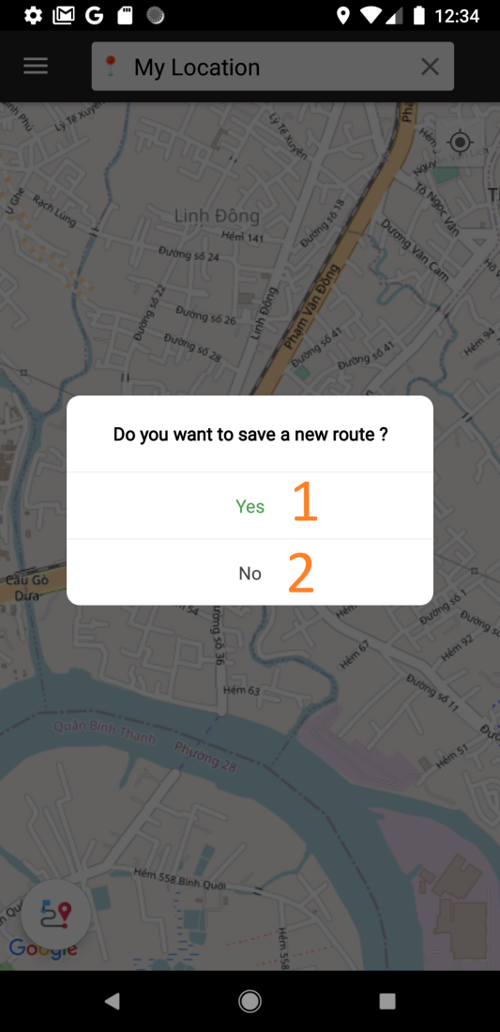

|  |  |  |  |  |
| --- | --- | --- | --- | --- |
| **No** | **Function** | **Description** | **Validation** | **Outcome** |
| 1 | Yes | Confirm to save route | N/A | Save user’s route to local storage |
| 2 | No | Confirm not to save route | N/A | Back to new routes screen |

#### 5.1.10 Confirm Share route

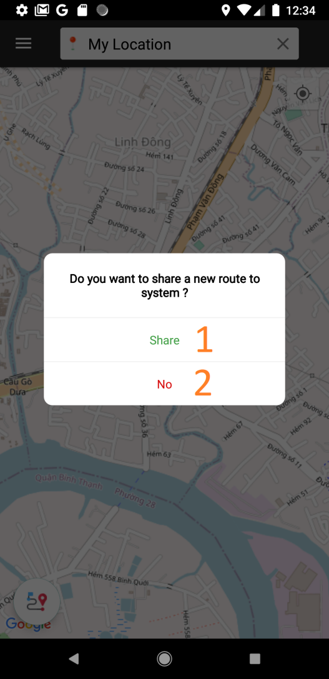

**Figure 78: Confirm Share route interface**

**Buttons/Hyperlinks:**

|  |  |  |  |  |
| --- | --- | --- | --- | --- |
| **No** | **Function** | **Description** | **Validation** | **Outcome** |
| 1 | Share | Share | Must have route to share | Add share route to system |
| 2 | No | No | Must have route to share | Back to route screen |

#### 5.1.11 My routes

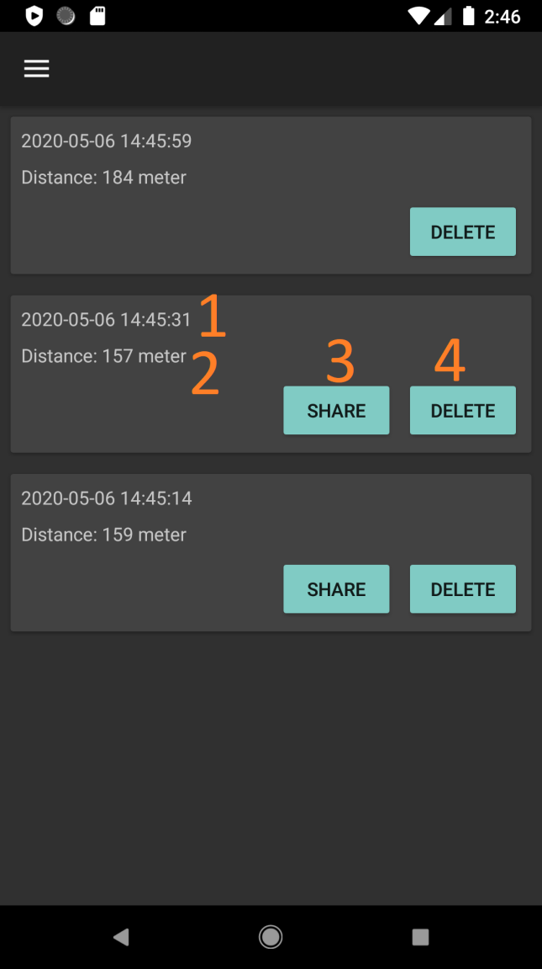

**Fields**

|  |  |  |  |  |  |  |  |
| --- | --- | --- | --- | --- | --- | --- | --- |
| **No** | **Field Name** | **Description** | **Read only** | **Mandatory** | **Control Type** | **Data Type** | **Length** |
| 1 | Date | Record time | Yes | Yes | Text | Datetime | N/A |
| 2 | Distance | Route’s distance | Yes | Yes | Text | String | N/A |

**Buttons/Hyperlinks:**

|  |  |  |  |  |
| --- | --- | --- | --- | --- |
| **No** | **Function** | **Description** | **Validation** | **Outcome** |
| 3 | Share | Share route | The route item must not been share before | Change status of tracking route to be shared  Route sent to the staff to wait for approval. |
| 4 | Delete | Delete route | N/A | Remove route from device local |

#### 5.1.12 Find route

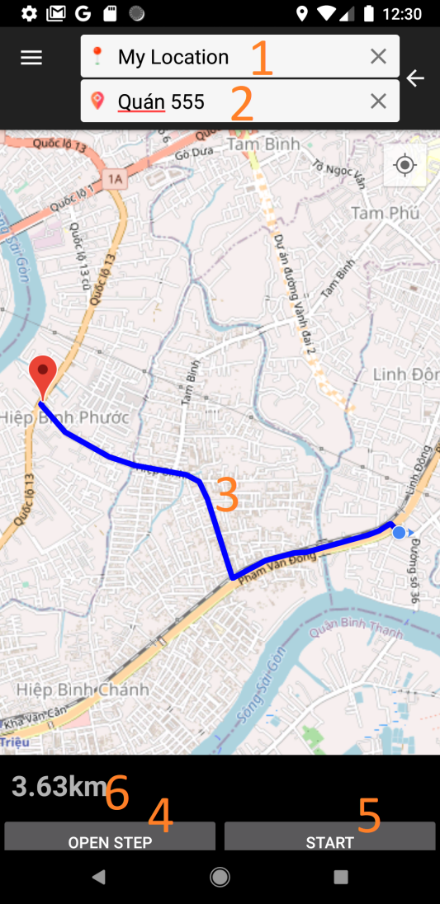

**Figure 80: Find route interface**

**Fields**

|  |  |  |  |  |  |  |  |
| --- | --- | --- | --- | --- | --- | --- | --- |
| **No** | **Field Name** | **Description** | **Read only** | **Mandatory** | **Control Type** | **Data Type** | **Length** |
| 1 | Origin | Input user’s origin | No | Yes | Text | String | N/A |
| 2 | Destination | Input user’s destination | No | Yes | Text | String | N/A |
| 3 | N/A | Drawing route | Yes | Yes | N/A | Polyline | N/A |
| 6 | Distance | Distance of route | Yes | Yes | Text | String | N/A |

**Buttons/Hyperlinks:**

|  |  |  |  |  |
| --- | --- | --- | --- | --- |
| **No** | **Function** | **Description** | **Validation** | **Outcome** |
| 4 | Open step | Open detail steps of route | Must have route from origin and destination | Redirect to detail step screen |
| 5 | Start | Start instruct user | Must have route from origin and destination | Redirect to instruct screen |

#### 5.1.13 Open step

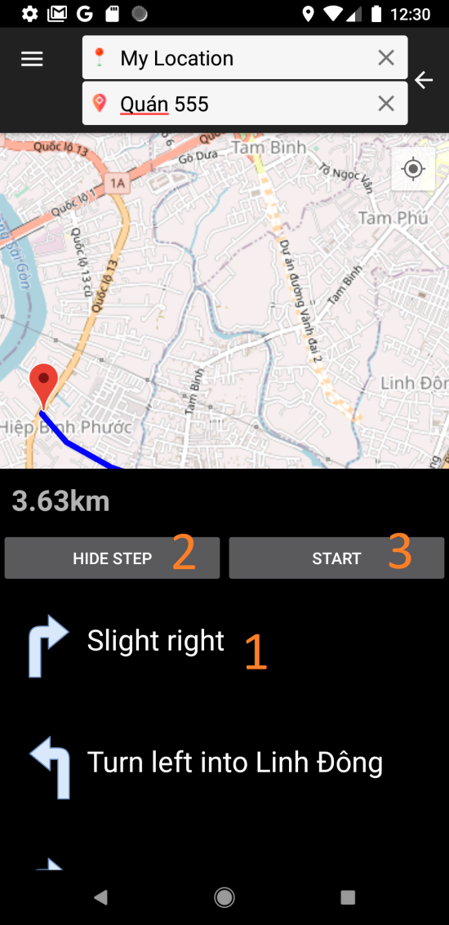

**Figure 81: Open step interface**

**Fields**

|  |  |  |  |  |  |  |  |
| --- | --- | --- | --- | --- | --- | --- | --- |
| **No** | **Field Name** | **Description** | **Read only** | **Mandatory** | **Control Type** | **Data Type** | **Length** |
| 1 | Step | Show step direction | Yes | Yes | Text | String | N/A |

**Buttons/Hyperlinks:**

|  |  |  |  |  |
| --- | --- | --- | --- | --- |
| **No** | **Function** | **Description** | **Validation** | **Outcome** |
| 2 | Hide step | Hide detail step | Must have show step direction | Back to find route screen |
| 3 | Start navigation | Start to navigate. | Must have route from origin and destination | Redirect to navigation |

#### 5.1.14 Route navigation screen

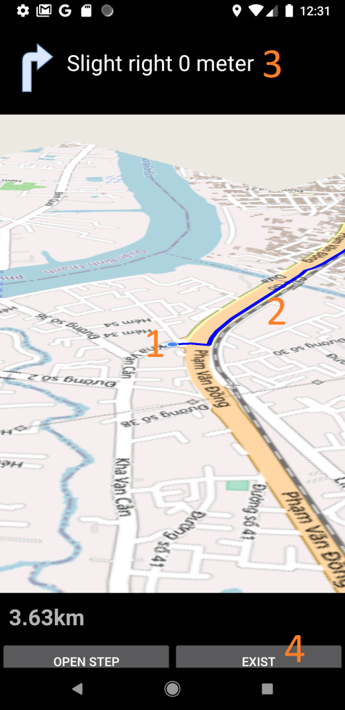

**Fields**

|  |  |  |  |  |  |  |  |
| --- | --- | --- | --- | --- | --- | --- | --- |
| **No** | **Field Name** | **Description** | **Read only** | **Mandatory** | **Control Type** | **Data Type** | **Length** |
| 1 | N/A | Current location | Yes | Yes | N/A | Lat, lng | N/A |
| 2 | N/A | User’s current route | Yes | Yes | N/A | Polyline | N/A |
| 3 | Next route step | Notify next route step | Yes | Yes | Text | String | N/A |

**Buttons/Hyperlinks:**

|  |  |  |  |  |
| --- | --- | --- | --- | --- |
| **No** | **Function** | **Description** | **Validation** | **Outcome** |
| 4 | Exit | Exit instruct | Must have instruct direction | Back to find route screen |

#### 5.1.15 Change route

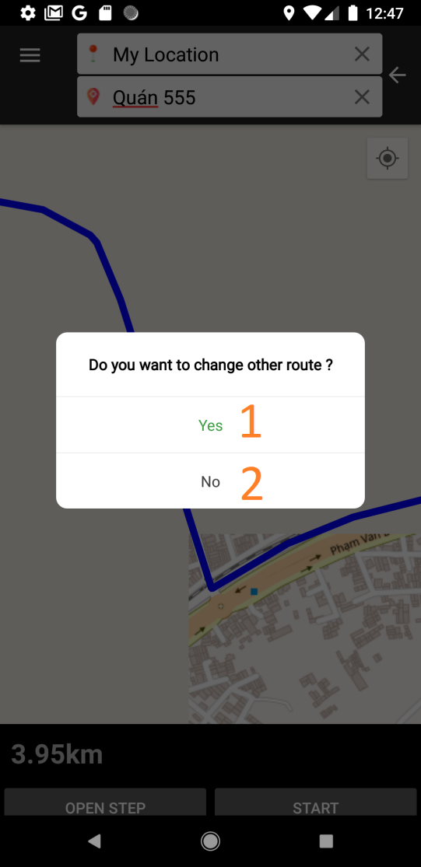

**Figure 83: Change route interface**

**Buttons/Hyperlinks:**

|  |  |  |  |  |
| --- | --- | --- | --- | --- |
| **No** | **Function** | **Description** | **Validation** | **Outcome** |
| 1 | Yes | Change to new route | Find route successfully | Find and draw alternative route |
| 3 | No | Keep old route | Find route successfully | Back to find route screen |

#### 5.1.16 Alternative route

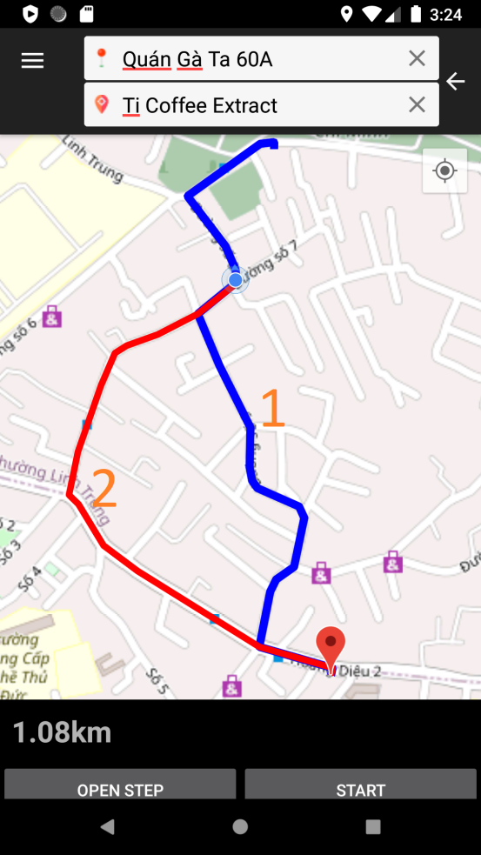

**Fields**

|  |  |  |  |  |  |  |  |
| --- | --- | --- | --- | --- | --- | --- | --- |
| **No** | **Field Name** | **Description** | **Read only** | **Mandatory** | **Control Type** | **Data Type** | **Length** |
| 1 | N/A | Old route | Yes | Yes | N/A | Polyline | N/A |
| 2 | N/A | Alternative route | Yes | Yes | N/A | Polyline | N/A |

#### 5.1.17 Out of range

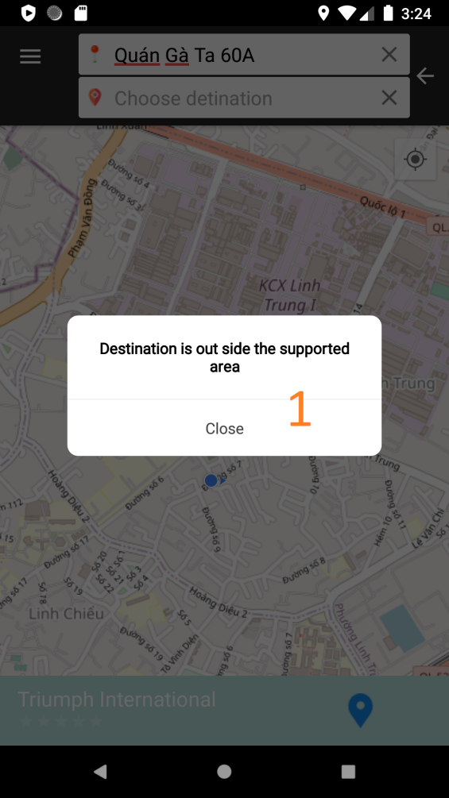

**Figure 85: Out of range interface**

**Buttons/Hyperlinks:**

|  |  |  |  |  |
| --- | --- | --- | --- | --- |
| **No** | **Function** | **Description** | **Validation** | **Outcome** |
| 1 | Close | Close | Must input origin and destination | Back to find route screen |

#### 5.1.18 Confirm alter route

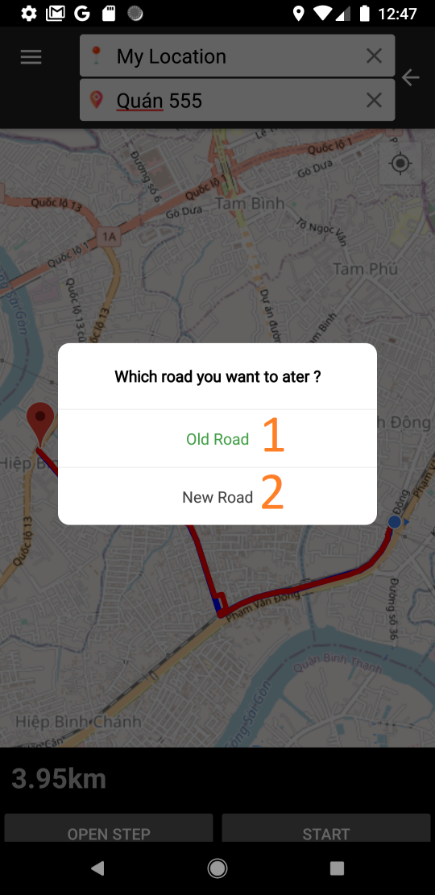

**Figure 86: Confirm alter route interface**

**Buttons/Hyperlinks:**

|  |  |  |  |  |
| --- | --- | --- | --- | --- |
| **No** | **Function** | **Description** | **Validation** | **Outcome** |
| 1 | Old road | Old road |  | Add share route to system |
| 2 | New road | New road |  | Back to route screen |

#### 5.1.19 Set Traffic jam

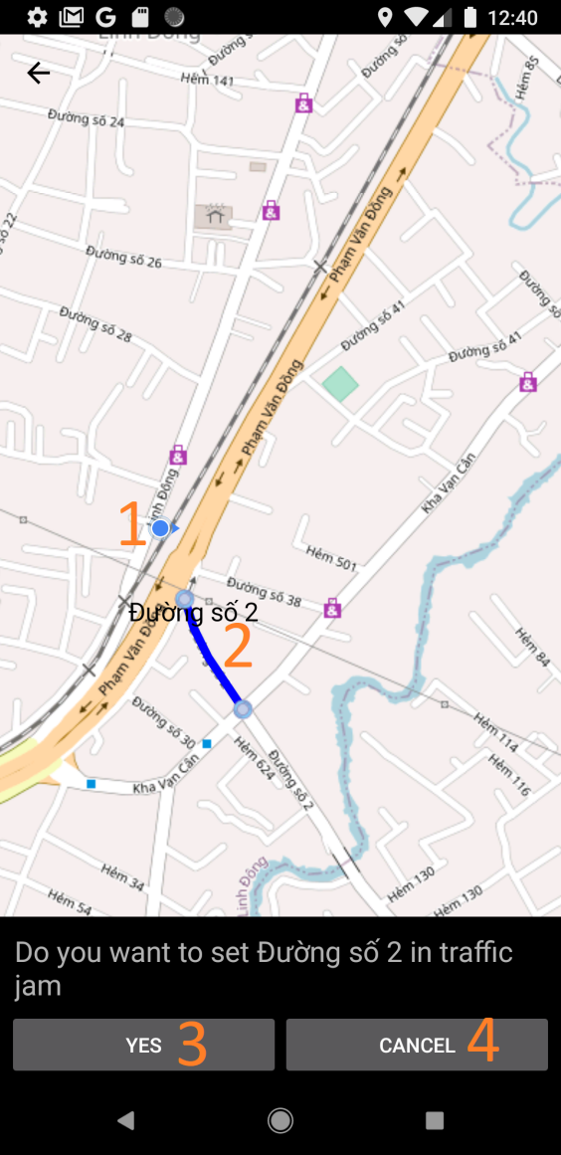

**Figure 87: Confirm alter route interface**

**Fields**

|  |  |  |  |  |  |  |  |
| --- | --- | --- | --- | --- | --- | --- | --- |
| **No** | **Field Name** | **Description** | **Read only** | **Mandatory** | **Control Type** | **Data Type** | **Length** |
| 1 | N/A | User’s current position | Yes | Yes | N/A | Lat, lng | N/A |
| 2 | N/A | Route want to set traffic jam | Yes | Yes | N/A | Polyline | N/A |

**Buttons/Hyperlinks:**

|  |  |  |  |  |
| --- | --- | --- | --- | --- |
| **No** | **Function** | **Description** | **Validation** | **Outcome** |
| 3 | Yes | Confirm to set traffic jam to route | Find route successfully | Route is marked that has traffic jams |
| 4 | Cancel | Cancel set traffic jam | Find route successfully | Cancel the report action |

#### 5.1.20 View traffic jam list

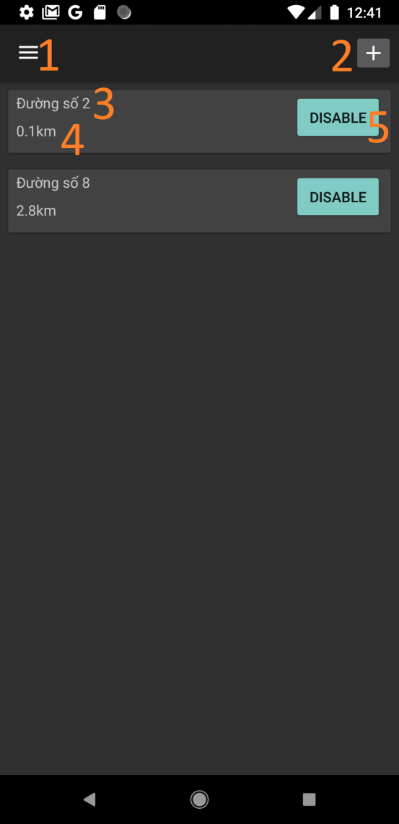

**Fields**

|  |  |  |  |  |  |  |  |
| --- | --- | --- | --- | --- | --- | --- | --- |
| **No** | **Field Name** | **Description** | **Read only** | **Mandatory** | **Control Type** | **Data Type** | **Length** |
| 1 | Road name | Name of reported route | Yes | Yes | N/A | String | N/A |
| 2 | Length | Reported route’s length | Yes | Yes | N/A | String | N/A |

**Buttons/Hyperlinks:**

|  |  |  |  |  |
| --- | --- | --- | --- | --- |
| **No** | **Function** | **Description** | **Validation** | **Outcome** |
| 1 | Menu | Open navigation bar | N/A | Open navigation bar |
| 2 | Report traffic jam | To map screen to set traffic jam | N/A | Direct to map for report traffic jam |
| 5 | Disable | Cancel the reported traffic jam | Traffic jam reported successfully | Route not to be marked has traffic jams. |

## 6. Database Design

### 6.1 Entity relationship diagram (ERD)

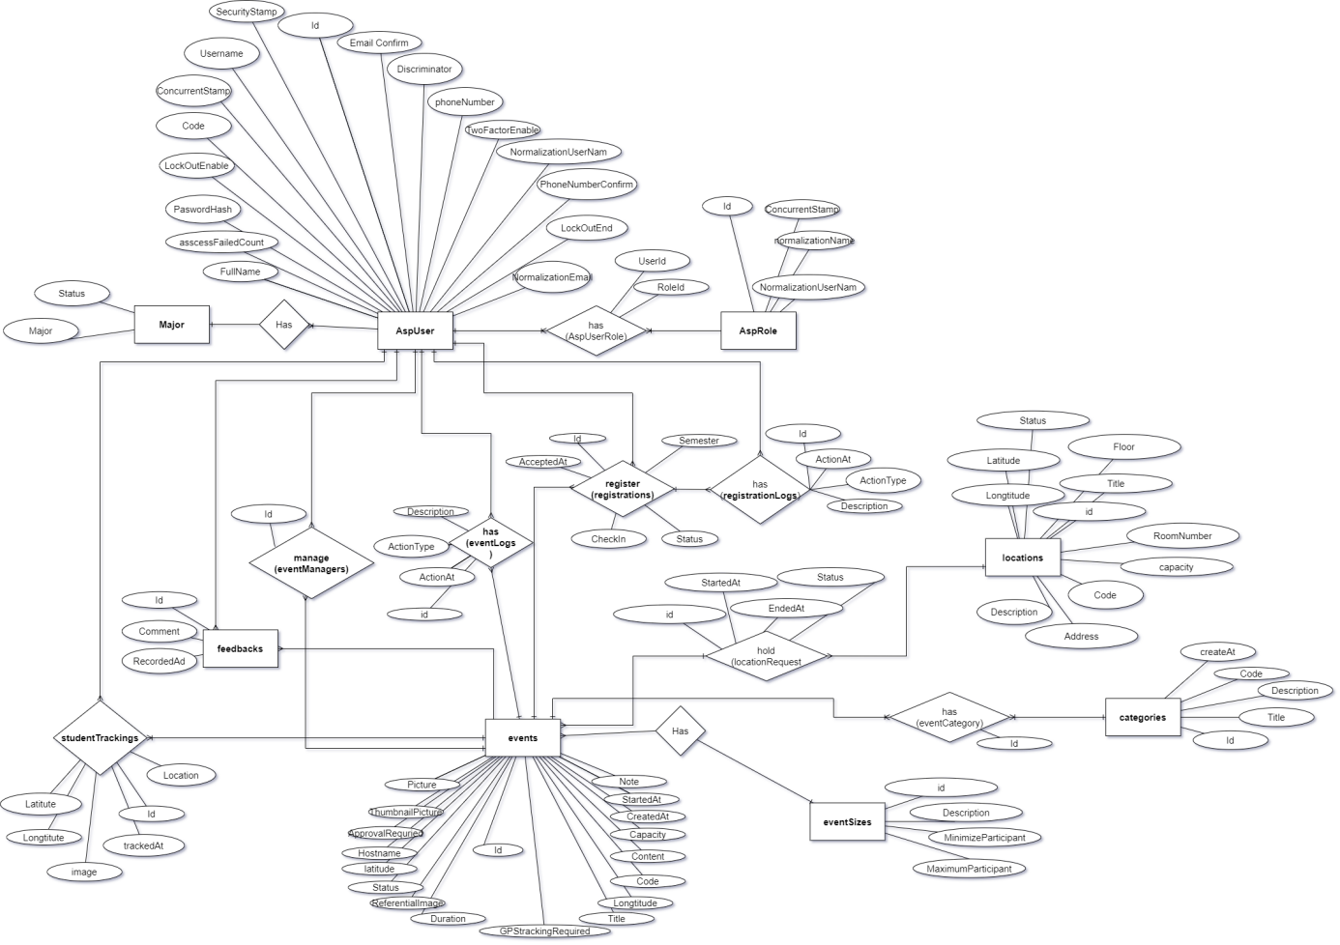

### 6.2 Data dictionary

|  |  |
| --- | --- |
| **Entity Data dictionary: describe content of all entities** | |
| **AspUser** | **Description** |
| **AspUserRole** | Contains the information of user |
| **AspRole** | Contains the information of what is the role of user |
| **RegistrationLogs** | Not exist in Conceptual diagram but needs to contain role of user |
| **Registrations** | Not exist in Conceptual diagram but need to contain registration of user |
| **StudentTracking** | Contain the information of registration |
| **EventLogs** | Not exist in Conceptual diagram but need to contain information of user in event |
| **Major** | Not exist in Conceptual diagram but need to contain history of user join in event |
| **Feedbacks** | Not exist in Conceptual diagram but need to contain information of major in FPT university |
| **EventManagers** | Not exist in Conceptual diagram but need to contain feedback of user to event |
| **Events** | Not exist in Conceptual diagram but need to contain information of who is managed event |
| **LocationRequests** | Contain the information of event |
| **Locations** | Not exist in Conceptual diagram but need to contain information of where is hold |
| **EventSize** | Not exist in Conceptual diagram but need to contain information of location |
| **EventCategorys** | Not exist in Conceptual diagram but need to contain information kind of event size |
| **Categories** | Not exist in Conceptual diagram but need to contain information what is the event size |
| **AspUser** | Not exist in Conceptual diagram but need to contain information kind of event category |

### 6.3 ERD Explanation

#### 6.3.1 AspUser Entity

|  |  |  |  |
| --- | --- | --- | --- |
| **Attribute** | **Type** | **Visibility** | **Description** |
| Id | Int | Private | Unique identifier of an user |
| Username | String | Private | User’s Name |
| NormalizedUserName | String | Private | User’s normalized user name |
| Email | String | Private | User’s email |
| NormalizedEmail | String | Private | User’s normalized email |
| EmailConfirmed | Boolearn | Private | User’s email status confirm |
| PasswordHash | String | Private | User’s password |
| SecurityStamp | String | Private | User’s security stamp |
| ConcurrencyStamp | String | Private | User’ currency stamp |
| PhoneNumber | String | Private | User’s phone number |
| PhoneNumberConfirmed | Boolearn | Private | User’s phone number status confirm |
| TwoFactorEnabled | Boolearn | Private | User’s factory status |
| LockoutEnd | DateTime | Private | User’ lockout date |
| LockoutEnabled | Boolearn | Private | User’s lockout status |
| AccessFailedCount | Int | Private | User’s count access failed |
| Discriminator | String | Private | User’s discriminator |
| Major | String | Private | User’s major |
| Code | String | Private | User’s code |
| FullName | String | Private | User’s fullname |

|  |  |  |  |
| --- | --- | --- | --- |
| **Method** | **Return type** | **Visibility** | **Description** |
| Getter | Data type | Public | Get attribute value |
| Setter | Void | Public | Set value of attribute |

#### 6.3.2 AspUserRole Entity

|  |  |  |  |
| --- | --- | --- | --- |
| **Attribute** | **Type** | **Visibility** | **Description** |
| RoleId | Int | Private | Role’s identifier for an account |
| UserId | Int | Private | User’s identifier for an account |

|  |  |  |  |
| --- | --- | --- | --- |
| **Method** | **Return type** | **Visibility** | **Description** |
| Getter | Data type | Public | Get attribute value |
| Setter | Void | Public | Set value of attribute |

#### 6.3.3 AspRole Entity

|  |  |  |  |
| --- | --- | --- | --- |
| **Attribute** | **Type** | **Visibility** | **Description** |
| Id | Int | Private | Unique identifier of a role |
| Name | String | Private | Role’s name |
| NormalizedName | String | Private | Role’s normalized name |
| ConcurrencyStamp | String | Private | Role’s concurrency stamp |

|  |  |  |  |
| --- | --- | --- | --- |
| **Method** | **Return type** | **Visibility** | **Description** |
| Getter | Data type | Public | Get attribute value |
| Setter | Void | Public | Set value of attribute |

#### 6.3.4 RegistrationLogs Entity

|  |  |  |  |
| --- | --- | --- | --- |
| **Attribute** | **Type** | **Visibility** | **Description** |
| Id | Int | Private | Unique identifier of registration logs |
| RegistrationId | Int | Private | Shortest_Route’s start node |
| UserId | Int | Private | User’s identifier for an registration logs |
| ActionAt | DateTime | Private | Registration’s date |
| ActionType | String | Private | Registration’s action type |
| Description | String | Private | Registration’s description |

|  |  |  |  |
| --- | --- | --- | --- |
| **Method** | **Return type** | **Visibility** | **Description** |
| Getter | Data type | Public | Get attribute value |
| Setter | Void | Public | Set value of attribute |

#### 6.3.5 Registrations Entity

|  |  |  |  |
| --- | --- | --- | --- |
| **Attribute** | **Type** | **Visibility** | **Description** |
| Id | Int | Private | Unique identifier of registration |
| EventId | Int | Private | Event’s identifier for an registration |
| UserId | Int | Private | User’s identifier for an registration |
| CreatedAt | DateTime | Private | Registration’s create date |
| CheckedIn | Boolearn | Private | Registration’s check in date |
| Semester | Int | Private | Registration’s semester |
| Status | Int | Private | Registration’s status |

|  |  |  |  |
| --- | --- | --- | --- |
| **Method** | **Redirect Type** | **Visibility** | **Description** |
| Getter | Data type | Public | Get attribute value |
| Setter | Void | Public | Set value of attribute |

#### 6.3.6 StudentTrackings Entity

|  |  |  |  |
| --- | --- | --- | --- |
| **Attribute** | **Type** | **Visibility** | **Description** |
| Id | Int | Private | Unique identifier of student tracking |
| EventId | Int | Private | Event’s identifier for student tracking |
| StudentId | Int | Private | User’s identifier for student tracking |
| TrackedAt | Date | Private | Student tracking’s tracked date |
| Latitude | Float | Private | Student tracking’s latitude |
| Longitude | Float | Private | Student tracking’s longtitude |
| Location | String | Private | Student tracking’s location |
| Image | String | Private | Student tracking’s image |

**Table 65: <Class Diagram Attribute> Notification**

|  |  |  |  |
| --- | --- | --- | --- |
| **Method** | **Return type** | **Visibility** | **Description** |
| Getter | Data type | Public | Get attribute value |
| Setter | Void | Public | Set value of attribute |

#### 6.3.7 EventLogs Entity

|  |  |  |  |
| --- | --- | --- | --- |
| **Attribute** | **Type** | **Visibility** | **Description** |
| Id | Int | Private | Unique identifier of event logs |
| EventId | String | Private | Formula’s name |
| UserId | Int | Private | User’s identifier for an event logs |
| ActionAt | Int | Private | Event log’s date |
| ActionType | DateTime | Private | Event log’s action type |
| Description | String | Private | Event log’s description |

|  |  |  |  |
| --- | --- | --- | --- |
| **Method** | **Return type** | **Visibility** | **Description** |
| Getter | Data type | Public | Get attribute value |
| Setter | Void | Public | Set value of attribute |

#### 6.3.9 Major Entity

|  |  |  |  |
| --- | --- | --- | --- |
| **Attribute** | **Type** | **Visibility** | **Description** |
| Major | String | Private | Unique identifier of major |
| Status | Int | Private | Major’s status |

|  |  |  |  |
| --- | --- | --- | --- |
| **Method** | **Return type** | **Visibility** | **Description** |
| Getter | Data type | Public | Get attribute value |
| Setter | Void | Public | Set value of attribute |

#### 6.3.10 Feedbacks Entity

|  |  |  |  |
| --- | --- | --- | --- |
| **Attribute** | **Type** | **Visibility** | **Description** |
| Id | Int | Private | Unique identifier of feed backs |
| EventId | String | Private | Event’s identifier for feedback |
| UserId | Int | Private | User’s identifier for feedback |
| Comment | String | Private | Feedback’s comment content |
| RecordedAt | DateTime | Private | Feedback’s date |

|  |  |  |  |
| --- | --- | --- | --- |
| **Method** | **Return type** | **Visibility** | **Description** |
| Getter | Data type | Public | Get attribute value |
| Setter | Void | Public | Set value of attribute |

#### 6.3.11 EventManagers Entity

|  |  |  |  |
| --- | --- | --- | --- |
| **Attribute** | **Type** | **Visibility** | **Description** |
| Id | Long | Private | Unique identifier of event’s manager |
| EventId | String | Private | Event’s identifier for event manager |
| UserId | Int | Private | User’s identifier for event manager |

|  |  |  |  |
| --- | --- | --- | --- |
| **Method** | **Return type** | **Visibility** | **Description** |
| Getter | Data type | Public | Get attribute value |
| Setter | Void | Public | Set value of attribute |

#### 6.3.12 Events Entity

|  |  |  |  |
| --- | --- | --- | --- |
| **Attribute** | **Type** | **Visibility** | **Description** |
| Id | Int | Private | Unique identifier of event |
| Title | String | Private | Event’s title |
| Content | String | Private | Event’s content |
| Duration |  |  | Event’s duration |
| Latitude | Float | Private | Student tracking’s latitude |
| Longitude | Float | Private | Student tracking’s longtitude |
| StartedAt | DateTime | Private | Event’s start date |
| GpsTrackingRequired | Boolearn | Private | Event’s gps tracking status |
| Capacity | Int | Private | Event’s maximum participants |
| CreatedAt | DateTime | Private | Event’s create date |
| Note | String | Private | Event’s note |
| EventSizeId | Int | Private | Size of event’s identifier for event |
| Status | String | Private | Event’s status |
| Picture | String | Private | Event’s picture |
| ThumbnailPicture | String | Private | Event’s thumbnail picture |
| HostName | String | Private | Event’s host name |
| ApprovalRequired | Boolearn | Private | Event’s approve status |
| ReferentialImage | String | Private | Event’s referential picture |
| Code | String | Private | Event’s code |

|  |  |  |  |
| --- | --- | --- | --- |
| **Method** | **Return type** | **Visibility** | **Description** |
| Getter | Data type | Public | Get attribute value |
| Setter | Void | Public | Set value of attribute |

#### 6.3.13 LocationRequest Entity

|  |  |  |  |
| --- | --- | --- | --- |
| **Attribute** | **Type** | **Visibility** | **Description** |
| Id | Int | Private | Unique identifier of request location |
| EventId | Int | Private | Event’s identifier for location request |
| LocationId | Int | Private | Location’s identifier for location request |
| StartedAt | DateTime | Private | Event request location start date |
| EndedAt | DateTime | Private | Event request location end date |
| Status | Int | Private | Location request’s status |

|  |  |  |  |
| --- | --- | --- | --- |
| **Method** | **Return type** | **Visibility** | **Description** |
| Getter | Data type | Public | Get attribute value |
| Setter | Void | Public | Set value of attribute |

#### 6.3.14 Locations Entity

|  |  |  |  |
| --- | --- | --- | --- |
| **Attribute** | **Type** | **Visibility** | **Description** |
| Id | Long | Private | Unique identifier of location |
| Code | String | Private | Location’s code |
| Description | String | Private | Location’s description |
| Capacity | Int | Private | Location’s maximum participant |
| Status | String | Private | Location’s status |
| Title | String | Private | Location’s title |
| Address | String | Private | Location’s address |
| RoomNumber | String | Private | Location’s room number |
| Floor | String | Private | Location’s floor |
| Latitude | Float | Private | Location’s latitude |
| Longitude | Float | Private | Location’s longtitude |

|  |  |  |  |
| --- | --- | --- | --- |
| **Method** | **Return type** | **Visibility** | **Description** |
| Getter | Data type | Public | Get attribute value |
| Setter | Void | Public | Set value of attribute |

#### 6.3.15 EventSizes Entity

|  |  |  |  |
| --- | --- | --- | --- |
| **Attribute** | **Type** | **Visibility** | **Description** |
| Id | Long | Private | Unique identifier of event size |
| Description | String | Private | Event size’s description |
| MinimizeParticipant | Int | Private | Event size’s minimum participant |
| MaximumParticipant | Int | Private | Event size’s maximum participant |

|  |  |  |  |
| --- | --- | --- | --- |
| **Method** | **Return type** | **Visibility** | **Description** |
| Getter | Data type | Public | Get attribute value |
| Setter | Void | Public | Set value of attribute |

#### 6.3.16 EventCategory Entity

|  |  |  |  |
| --- | --- | --- | --- |
| **Attribute** | **Type** | **Visibility** | **Description** |
| Id | Int | Private | Unique identifier of event category |
| EventId | Int | Private | Event’s identifier for location request |
| CategoryId | Int | Private | Event category’s identifier for location request |

|  |  |  |  |
| --- | --- | --- | --- |
| **Method** | **Return type** | **Visibility** | **Description** |
| Getter | Data type | Public | Get attribute value |
| Setter | Void | Public | Set value of attribute |

#### 6.3.17 Categories Entity

|  |  |  |  |
| --- | --- | --- | --- |
| **Attribute** | **Type** | **Visibility** | **Description** |
| Id | Int | Private | Unique identifier of categories |
| Code | String | Private | Category’s code |
| Title | String | Private | Category’s title |
| Description | String | Private | Category’s description |
| CreateAt | DateTime | Private | Category’s create date |

|  |  |  |  |
| --- | --- | --- | --- |
| **Method** | **Return type** | **Visibility** | **Description** |
| Getter | Data type | Public | Get attribute value |
| Setter | Void | Public | Set value of attribute |

## 7. Algorithms

# **E. System Implementation & Test**

## 1. Introduction

### 1.1 Overview

* This section describes the approach and methods we used in testing of the APT system. It contains information about the testing procedure of the system including test plans, test cases, test result, test environments and risks estimations as a checklist form.

### 1.2 Test approach

* Goal: Test all core flow features in the APT system.
* Method: black-box testing
* Technique: check list
* Testing for the APT project includes testing each function and testing the system integration. Testing APT project as a completed system to ensure that whole systems must match the software requirements.
* Testing would be performed by all team members and approved by the team leader.
* The testing focuses on judging the reliability of the APT system. This process involves finding unexpected outputs, concerned with many unanticipated interactions from the system components.

## 2. Database Relationship Diagram

### 2.1 Physical Diagram

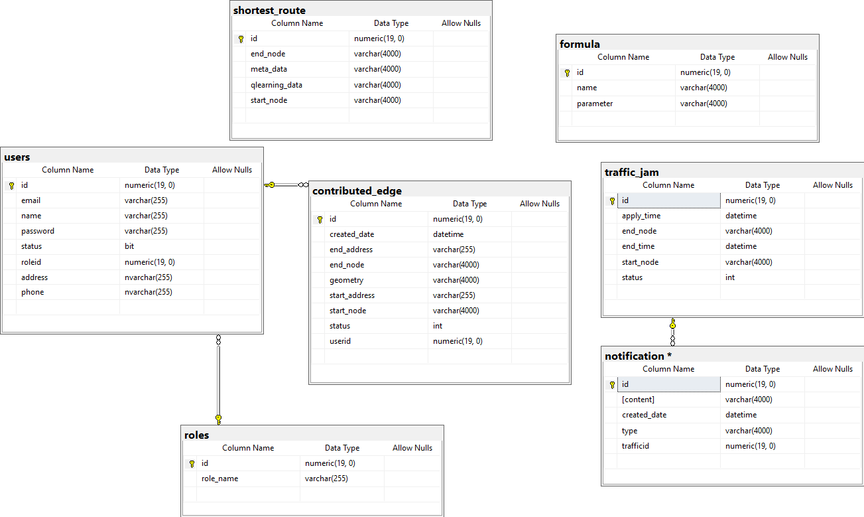

### 2.2 Data dictionary

|  |  |
| --- | --- |
| **Entity Data dictionary: describe content of all entities** | |
| Entity Name | Description |
| Users | Table which contains all user’s information |
| Roles | Table which contains all role of user information |
| Contributed Edge | Table which contains route contributed by user |
| Shortest Route | Table which contains all shortest route information |
| Traffic Jam | Table which contains all traffic jam information |
| Notification | Table which contains all notification information |
|  |  |
|  |  |
|  |  |
|  |  |

|  |  |  |  |  |
| --- | --- | --- | --- | --- |
| **Entity name** | **Attributes** | **Domain** | **Null** | **Description** |
| User | Id | numeric(19,0) | No | Unique user code |
| Email | nvarchar(255) | No | Unique Email of user |
| Password | nvarchar(255) | No | Password of user |
| Name | nvarchar(255) | No | Name of user |
| roleid | numeric(19,0) | No | Role id |
| address | nvarchar(255) | No | Address of user |
| phone | nvarchar(255) | Noo | Phone of user |
| Role | Id | numeric(19,0) | No | Unique role id |
| role_name | nvarchar(255) | No | Name of role |
| AspUser | Id | numeric(19,0) | No | Unique traffic jam id |
| Apply_time | datetime | No | Traffic jam apply time |
| End_time | datetime | No | Traffic Jam end time |
| status | int | No | Status of traffic jam |
| Start_node | nvarchar(4000) | No | Information of start node |
| End_node | nvarchar(4000) | No | Information of end node |
| AspUserRole | RoleId | Int | Private | Role’s identifier for an account |
| UserId | Int | Private | User’s identifier for an account |
| AspRole | Id | Int | Private | Unique identifier of a role |
| Name | String | Private | Role’s name |
| NormalizedName | String | Private | Role’s normalized name |
| ConcurrencyStamp | String | Private | Role’s concurrency stamp |
| RegistrationLogs | Id | Int | Private | Unique identifier of registration logs |
| RegistrationId | Int | Private | Shortest_Route’s start node |
| UserId | Int | Private | User’s identifier for an registration logs |
| ActionAt | DateTime | Private | Registration’s date |
| ActionType | String | Private | Registration’s action type |
| Description | String | Private | Registration’s description |
| Registrations | Id | Int | Private | Unique identifier of registration |
| EventId | Int | Private | Event’s identifier for an registration |
| UserId | Int | Private | User’s identifier for an registration |
| CreatedAt | DateTime | Private | Registration’s create date |
| CheckedIn | Boolearn | Private | Registration’s check in date |
| Semester | Int | Private | Registration’s semester |
| Status | Int | Private | Registration’s status |
| StudentTracking | Id | Int | Private | Unique identifier of student tracking |
| EventId | Int | Private | Event’s identifier for student tracking |
| StudentId | Int | Private | User’s identifier for student tracking |
| TrackedAt | Date | Private | Student tracking’s tracked date |
| Latitude | Float | Private | Student tracking’s latitude |
| Longitude | Float | Private | Student tracking’s longtitude |
| Location | String | Private | Student tracking’s location |
| Image | String | Private | Student tracking’s image |
| Eventlogs | Id | Int | Private | Unique identifier of event logs |
| EventId | String | Private | Formula’s name |
| UserId | Int | Private | User’s identifier for an event logs |
| ActionAt | Int | Private | Event log’s date |
| ActionType | DateTime | Private | Event log’s action type |
| Description | String | Private | Event log’s description |
| Major | Major | String | Private | Unique identifier of major |
| Status | Int | Private | Major’s status |
| Feedbacks | Id | Int | Private | Unique identifier of feed backs |
| EventId | String | Private | Event’s identifier for feedback |
| UserId | Int | Private | User’s identifier for feedback |
| Comment | String | Private | Feedback’s comment content |
| RecordedAt | DateTime | Private | Feedback’s date |
| EventManagers | Id | Long | Private | Unique identifier of event’s manager |
| EventId | String | Private | Event’s identifier for event manager |
| UserId | Int | Private | User’s identifier for event manager |
| Events | Id | Int | Private | Unique identifier of event |
| Title | String | Private | Event’s title |
| Content | String | Private | Event’s content |
| Duration |  |  | Event’s duration |
| Latitude | Float | Private | Student tracking’s latitude |
| Longitude | Float | Private | Student tracking’s longtitude |
| StartedAt | DateTime | Private | Event’s start date |
| GpsTrackingRequired | Boolearn | Private | Event’s gps tracking status |
| Capacity | Int | Private | Event’s maximum participants |
| CreatedAt | DateTime | Private | Event’s create date |
| Note | String | Private | Event’s note |
| EventSizeId | Int | Private | Size of event’s identifier for event |
| Status | String | Private | Event’s status |
| Picture | String | Private | Event’s picture |
| ThumbnailPicture | String | Private | Event’s thumbnail picture |
| HostName | String | Private | Event’s host name |
| ApprovalRequired | Boolearn | Private | Event’s approve status |
| ReferentialImage | String | Private | Event’s referential picture |
| Code | String | Private | Event’s code |
| Locations | Id | Int | Private | Unique identifier of request location |
| EventId | Int | Private | Event’s identifier for location request |
| LocationId | Int | Private | Location’s identifier for location request |
| StartedAt | DateTime | Private | Event request location start date |
| EndedAt | DateTime | Private | Event request location end date |
| Status | Int | Private | Location request’s status |
| Eventsizes | Id | Long | Private | Unique identifier of event size |
| Description | String | Private | Event size’s description |
| MinimizeParticipant | Int | Private | Event size’s minimum participant |
| MaximumParticipant | Int | Private | Event size’s maximum participant |
| EventCategory | Id | Int | Private | Unique identifier of event category |
| EventId | Int | Private | Event’s identifier for location request |
| CategoryId | Int | Private | Event category’s identifier for location request |
| EventCategory | Id | Int | Private | Unique identifier of categories |
| Code | String | Private | Category’s code |
| Title | String | Private | Category’s title |
| Description | String | Private | Category’s description |
| CreateAt | DateTime | Private | Category’s create date |

## 3. Test plan

The purpose of this testing is to ensure the APT project meets all technical rules, functions and fits business documents. This subsection describes the overall test plan and strategy for testing APT .

### 3.1 Features to be tested

* Admin: Ban/Unban SO Account
* Service Officer:
  + Manage event : create/ edit/ delete event
  + Manage registration: cancel registration
* Student:
  + Register event
  + Cancel registration
  + Check In
  + Update profile
* System:
  + Tracking user information

### 3.2 Features not to be tested

* All roles:. cái chức nằng nào hông thể test team cập nhật vào

## 4. System Testing Test Case

### 4.1 Communication Diagram

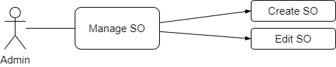

*Figure 82: Admin Communication Diagram*

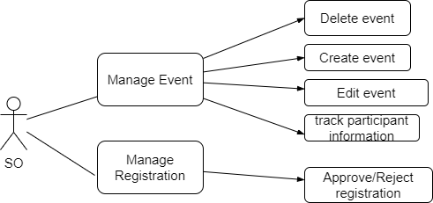

*Figure 83: Service Officer Communication Diagram*

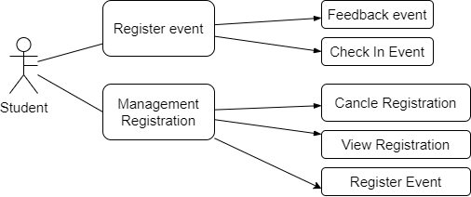

*Figure 84: Student Communication Diagram*

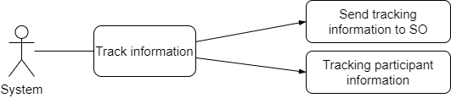

*Figure 84: System Communication Diagram*

### 4.2 Test Case

#### 4.2.1 <Admin> Change Account Status

|  |  |  |  |  |  |
| --- | --- | --- | --- | --- | --- |
| **ID** | **Test Case Description** | **Test case procedure** | **Expected output** | **Result** | **Test Date** |
| **MA_1** | Test Update Account Status is Active. | 1 - Admin click the “Disable” button In active User account item  2 - Choose Yes to Dialog “Do you want to lock this account?” | 1 - System show messages “Lock this user successful”  2 - Locked item account has background color is light red  3 - User account cannot login to the system anymore | Pass | 04/12/2020 |
| **MA_2** | Test Update Account Status is Inactive. | 1 - Admin click the “Enable” button In inactive User account item  2 - Choose Yes to Dialog “Do you want to unlock this account?” | 1 - System show messages “Unlock this user successful”  2 - Unocked item account has background color back to white.  2 - User account can login to the system normally | Pass | 04/12/2020 |

*Table: <Admin> Manage Account Test case*

#### 4.2.2 <Service Officer> Manage registration

|  |  |  |  |  |  |
| --- | --- | --- | --- | --- | --- |
| **ID** | **Test Case Description** | **Test case procedure** | **Expected output** | **Result** | **Test Date** |
| **MTR_1** | Approve Registration | 1 - SO click on registration item.  2 - click on “Approve” button  3 - Confirm dialog | 1 - System reloads Request list and shows that the confirmed item had been changed status in request. (confirm completed)  2 – System update status of registration. | Pass | 04/12/2020 |
| **MTR_2** | Reject Registration | 1 - SO click on registration item.  2 - click on “Reject” button  3 - Confirm dialog | 1 - System reloads Request list and shows that the confirmed item had been changed status in request. (confirm completed)  2 – System update status of registration. | Pass | 04/12/2020 |

*Table: <Admin> Accept Request test case*

#### 4.2.3 <Service officer> Manage Event

|  |  |  |  |  |  |
| --- | --- | --- | --- | --- | --- |
| **ID** | **Test Case Description** | **Test case procedure** | **Expected output** | **Result** | **Test Date** |
| **MTJ_1** | Create event | 1 - SO click create event button   1. SO input information valid 2. SO click create | 1 - System shows form create for user  2 – System check valid form  3 - Response message and create new event | Pass | 04/12/2020 |
| **MTJ _2** | Delete event. | 1 - SO Click remove event   1. SO confirm on dialog | 1-System show dialog for user  2 - System remove event from database and reload view view for user | Pass | 04/12/2020 |
| **MTJ _3** | Edit event | 1 - Staff select event which want to edit.  2 - Click edit button  3 - Input valid data to from edit  4 - Click button update | 1. System shows edit form for user 2. System check valid information 3. System update event information 4. System reload view for user | Pass | 04/12/2020 |
|  | Tracking event information | 1. User tracking email for information of participant | - system send mail about participant after check in per 5 minutes | Pass | 04/12/2020 |

*Table: <Staff> Manage Traffic Jam test case*

#### 4.2.4 <Student> Manage Registrations

|  |  |  |  |  |  |
| --- | --- | --- | --- | --- | --- |
| **ID** | **Test Case Description** | **Test case procedure** | **Expected output** | **Result** | **Test Date** |
| **MCTJ_1** | View registration | 1 - User click on manage registration  2 - user view all list registration with status  3 user can action such as view, cancle, edit | 1 - System get information from database  2, response data to view of user | Pass | 04/12/2020 |
|  | Cancel registration | 1. User select registration and click cancel 2. User click yes on dialog 3. User view reloaded page | 1. System shows confirm box for user 2. System update status of registration 3. System reload view response to user | Pass | 04/12/2020 |
|  | Register Event | 1. User click register on vent 2. User confirm dialog | 1. System check condition for registration 2. Create new registration for user 3. Show success message | Pass | 04/12/2020 |

*Table: <Student> Manage Registration test case*

#### 4.2.5 <Student> Manage Events

|  |  |  |  |  |  |
| --- | --- | --- | --- | --- | --- |
| **ID** | **Test Case Description** | **Test case procedure** | **Expected output** | **Result** | **Test Date** |
| **FL_1** | Check In Event. | 1 - User select event  2 - User click check in event  3 - user allow tracking location  4 - view success message | 1 - System show confirm tracking location diagram for user  2 - System update user registration  3 - System show message success | Pass | 04/12/2020 |
| **FL _3** | Feedback event | 1. User click on feedback 2. User input information 3. Click send | 1 - System show notify take feedback  2 - check valid information  3 - save information in database and response to user | Pass | 04/12/2020 |

*Table: <Member> Find Location test case*

*Table: < Collaborator> Report Clear Traffic Jam test case*

#### 4.2.11 <System> Tracking information

|  |  |  |  |  |  |
| --- | --- | --- | --- | --- | --- |
| **ID** | **Test Case Description** | **Test case procedure** | **Expected output** | **Result** | **Test Date** |
| **CTJ_1** | When user check in success then tracking system handler per 5 minute about sending tracking information |  | 1 - System send information about user such as user’s location to SO/admin | Pass | 04/12/2020 |

*Table: <System> Tracking user information test case*

# **F. Software User’s Manual**

## 1. Installation Guide

### 1.1 Setting up environment at server side

#### 1.1.1 Hardware requirements

|  |  |  |
| --- | --- | --- |
| **Server** | **Minimum Requirements** | **Recommended** |
| **Internet Connection** | Cable, Wi-Fi (8 Mbps) | Cable, Wi-Fi (50 Mbps or more) |
| **Operating System** | 10, Window Server 2016 | 10, Window Server 2016 |
| **Computer Processor** | Intel® Xeon ® 1.4GHz | Intel® Xeon ® Quad Core (12M Cache, 2.50 GHz) |
| **Computer Memory** | 4GB RAM | 32GB or more |
| **Storage space** | 5GB | 10GB or more |

#### 1.1.2 Software requirements

|  |  |  |
| --- | --- | --- |
| **Operating System** | Window 10 | Operating system and platform for development |
| **Modeling tool** | StarUML | Used to design diagram |
| **IDE** | Netbean 11.2, Android Studio 3.5 or newer | Programming tools |
| **DBMS** | SQL Server 2017 | Used to create & manage the database for system |
| **Web server** | Tomcat 8 | Deployment environment |
| **Source control** | Github | Used for source control |
| **Web browser** | chromium based browsers latest two version, firefox latest two version | Testing browser |

### 1.2 Deployment at server side

1. Put packaging <war> property in pom.xml

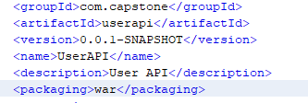

1. Login to amazon console

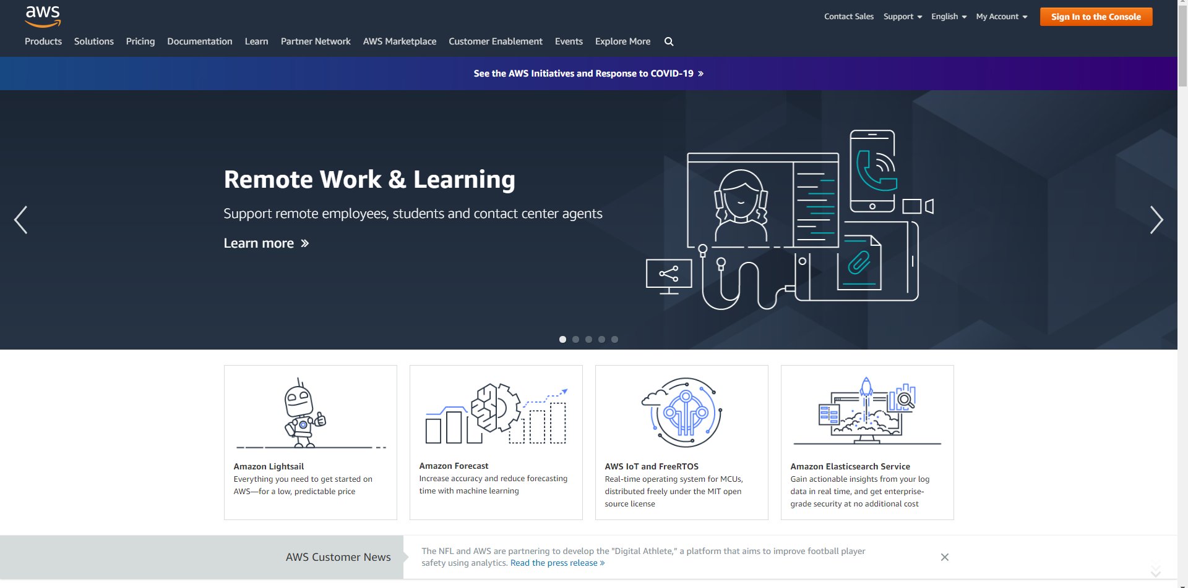

1. Choose RDS to create a new database

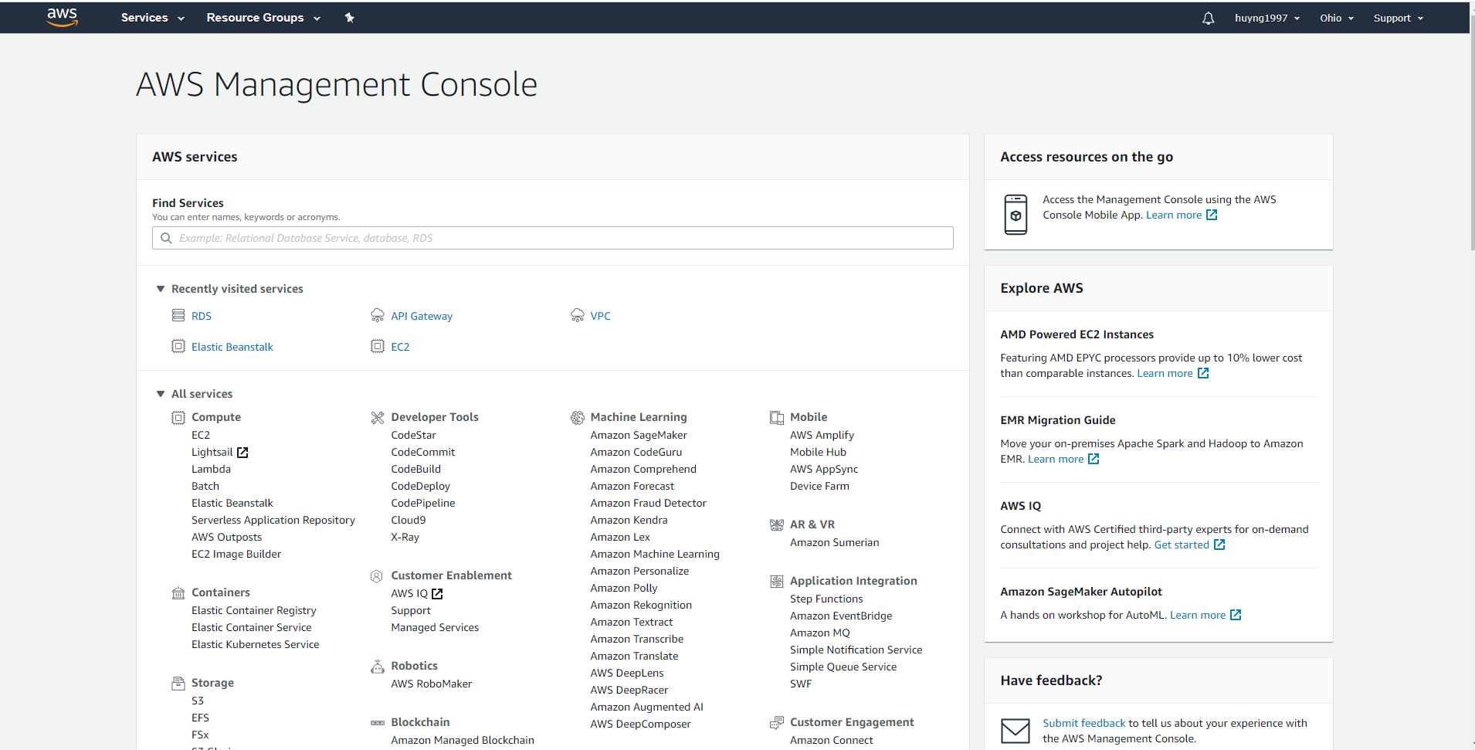

1. Create Database

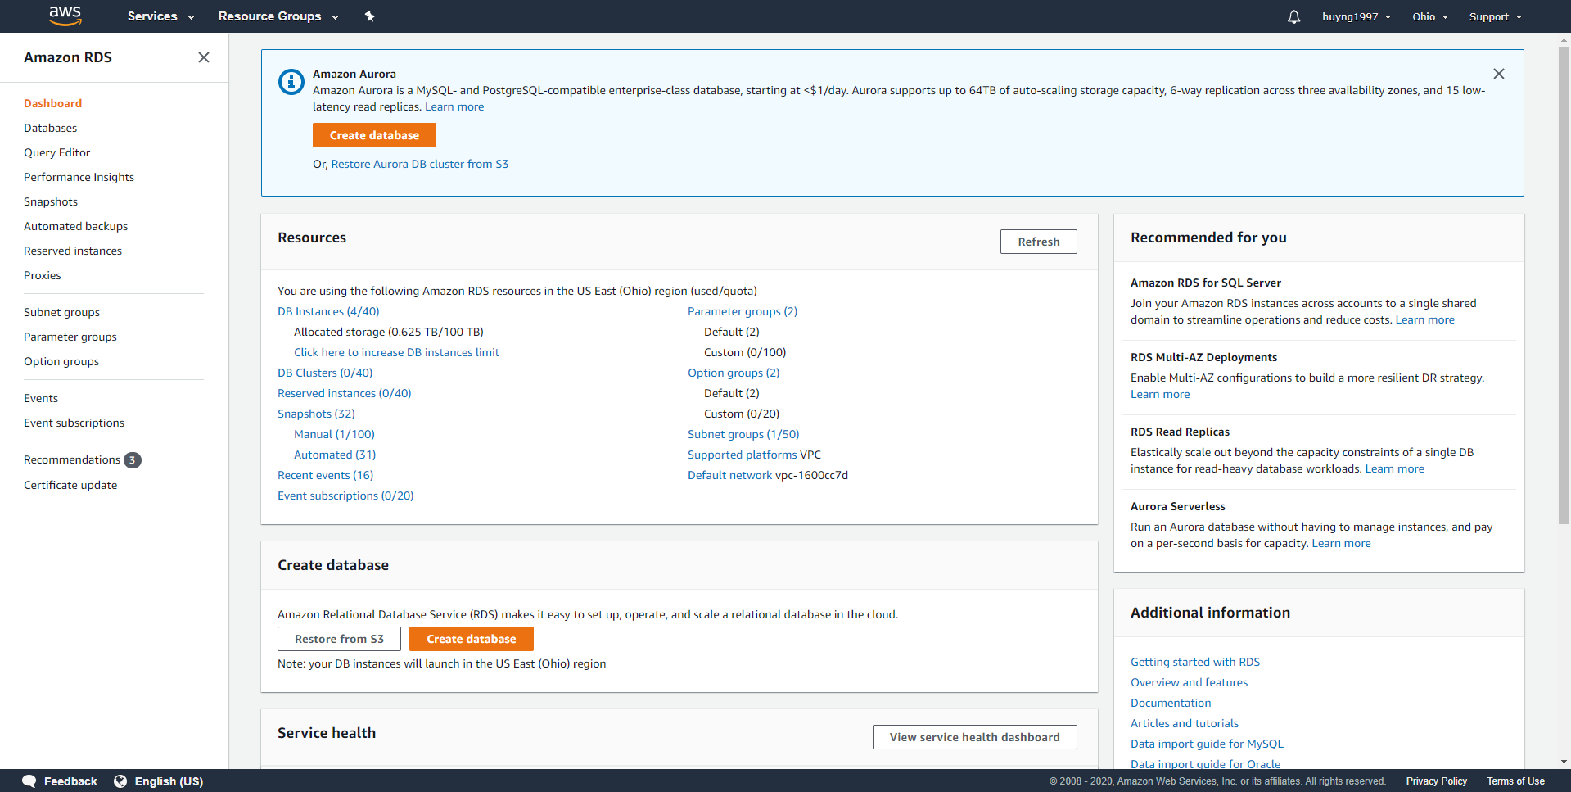

1. Choose SQL Server

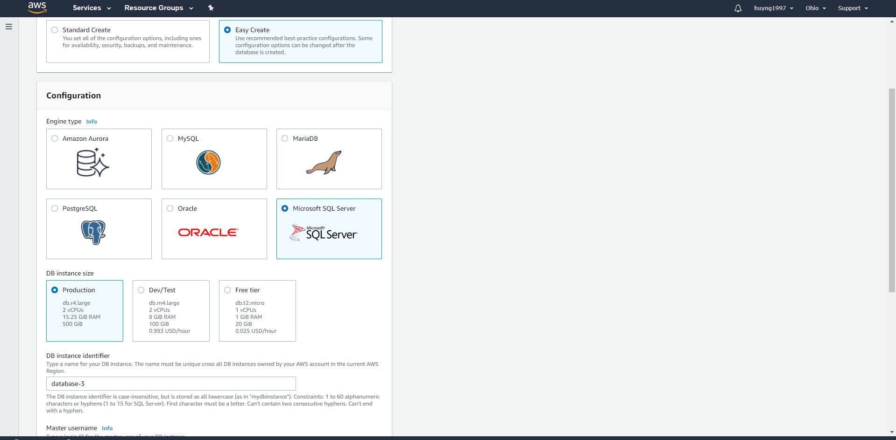

1. Choose username and password then click create database

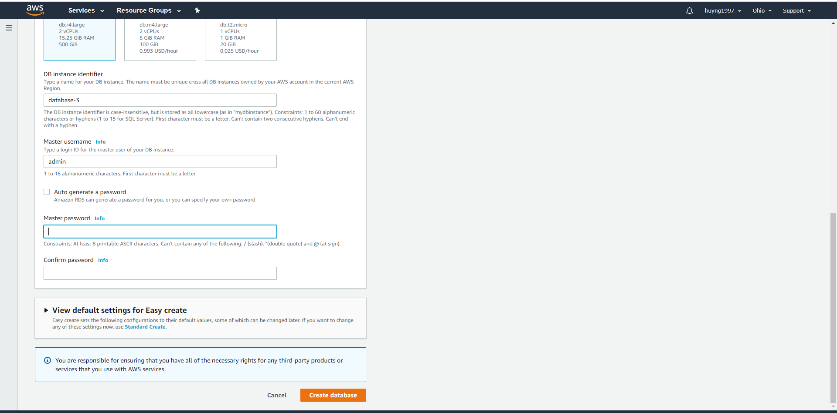

1. Go to the database we just have created

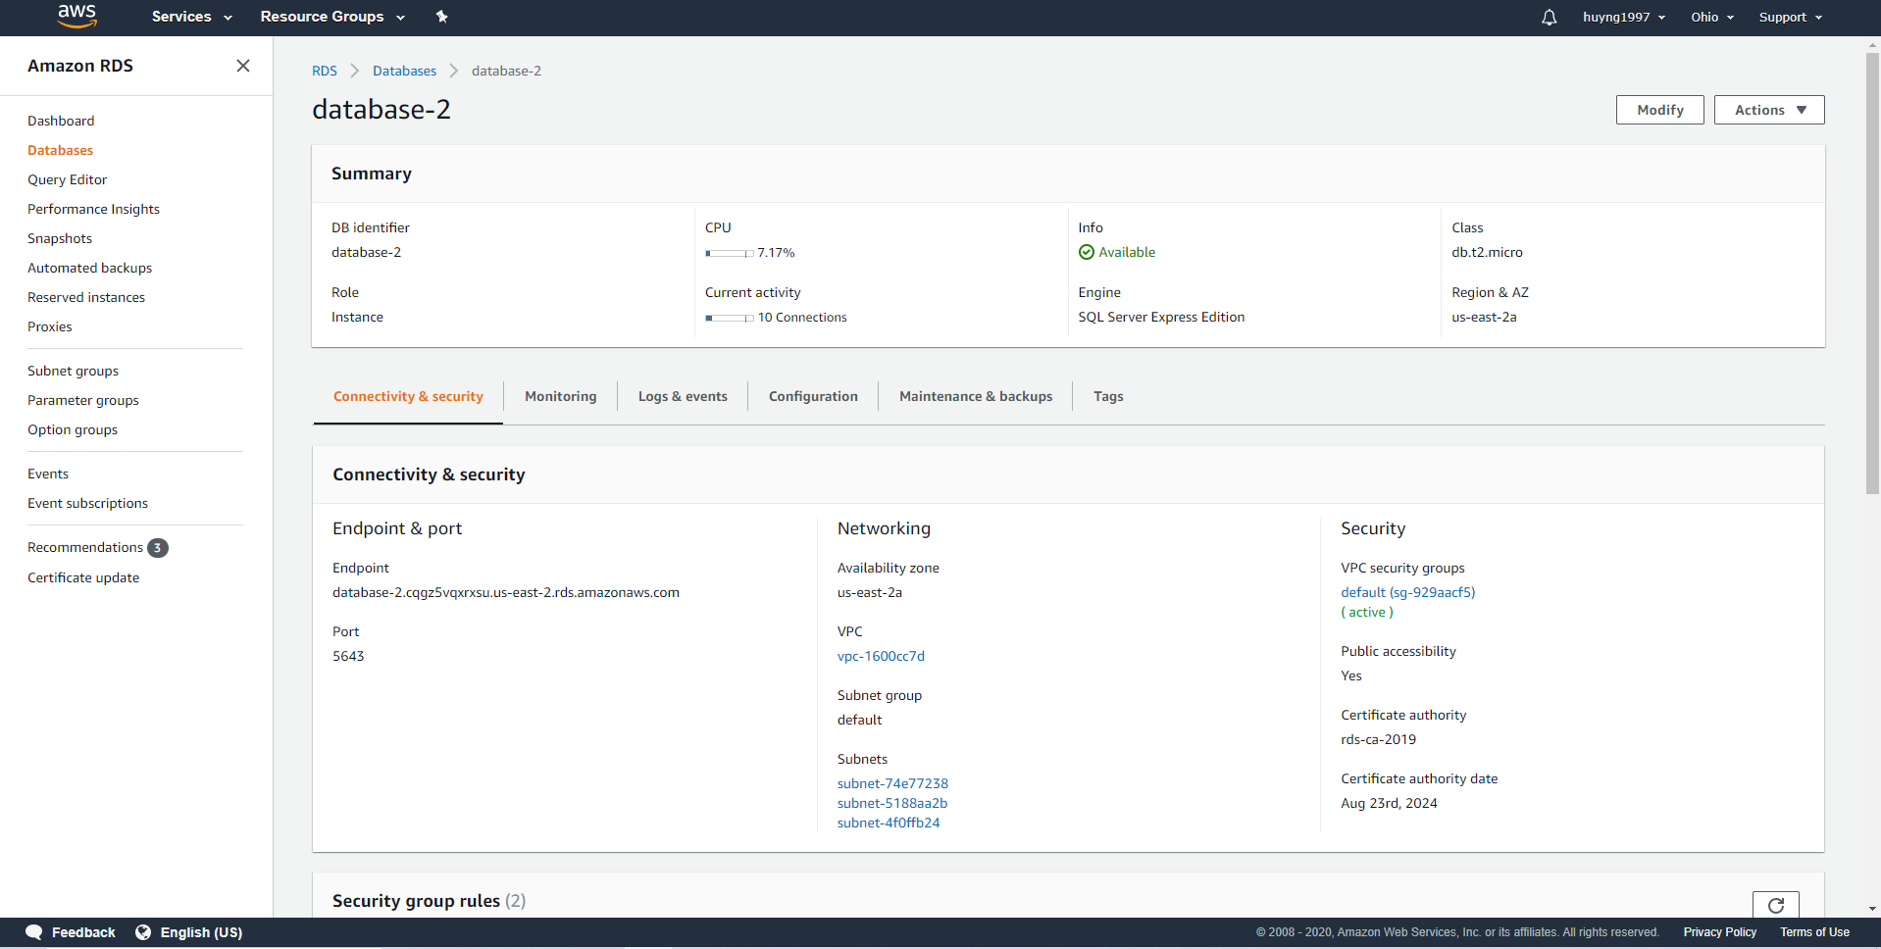

1. Copy Endpoint and port into the application.properties file in the application like this



1. Now connect to the database we just have created by using SQL management studio

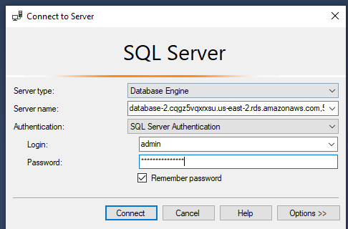

1. Choose your own database name then create(Here is RestfulAPI)
2. Now clean and build the application to get .war file

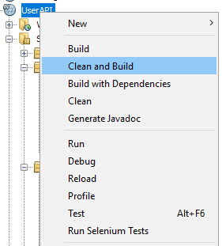

1. Go to AWS console and choose elastic beantalk

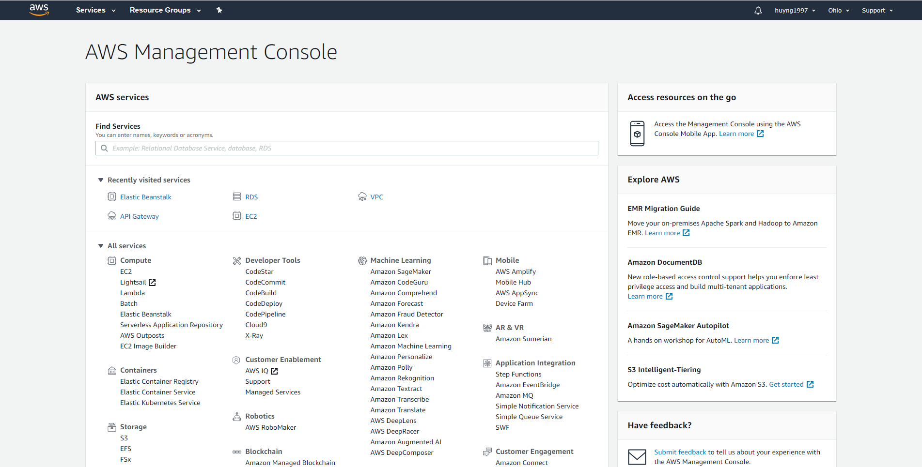

1. Create a new environment

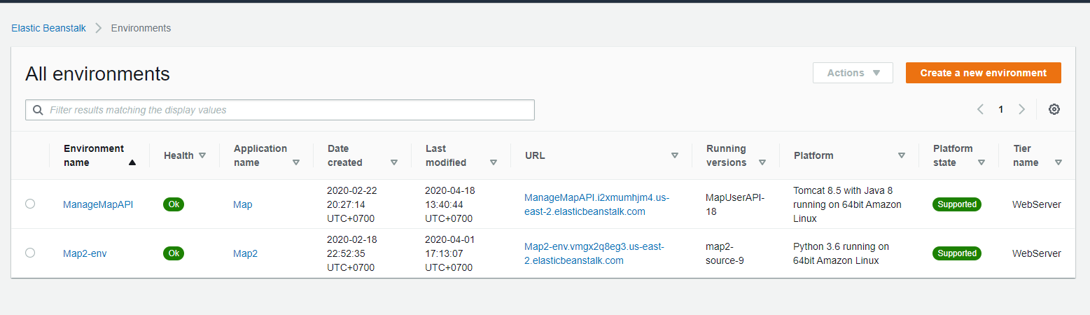

1. Because our application is implemented under REST api so choose Web Server Environment

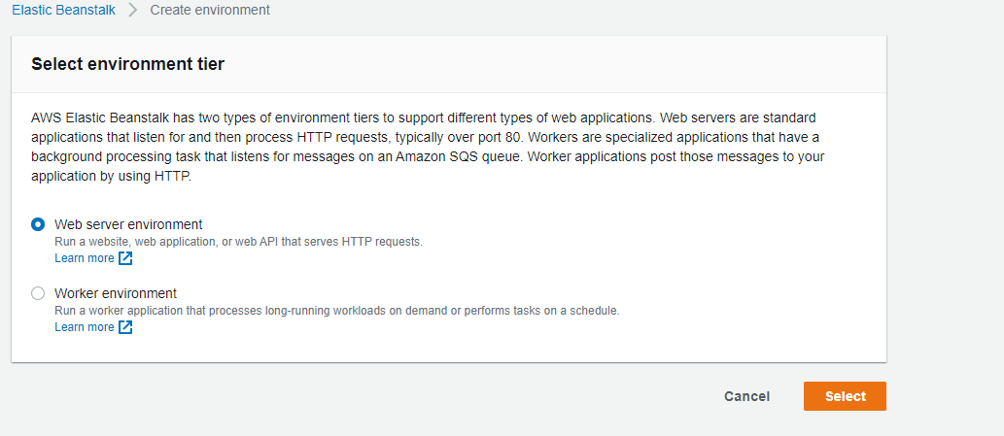

1. Create name and choose tomcat platform then create environment

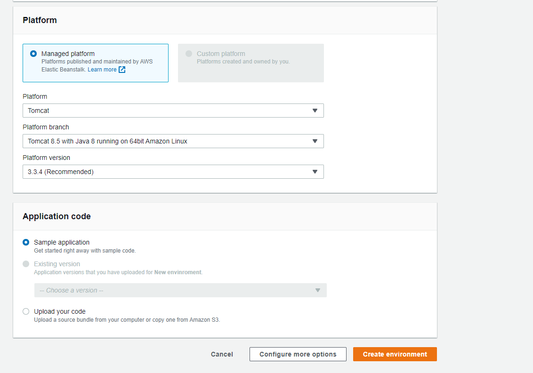

1. Wait the environment to be created

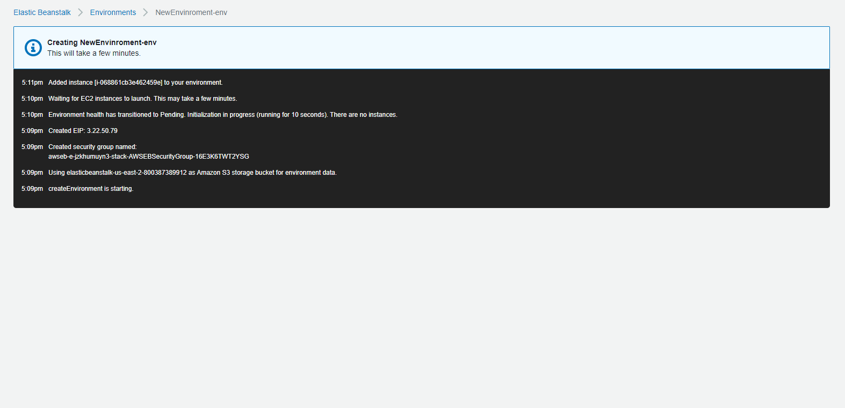

1. Go to the new environment we just have created then select upload and deploy

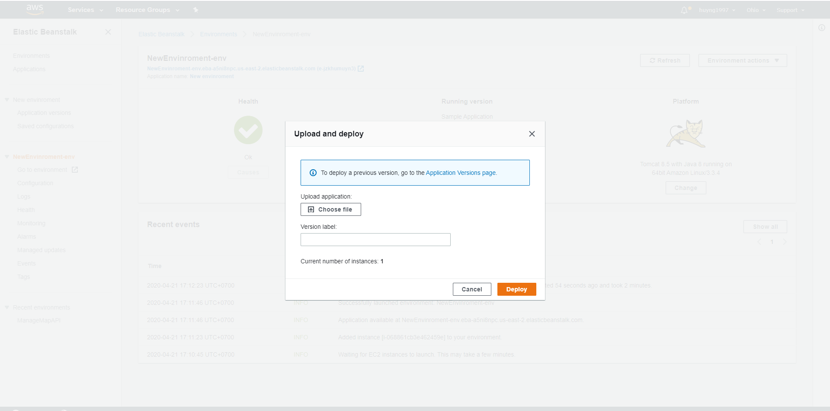

10 Choose .war file that we just have built in the target folder of application

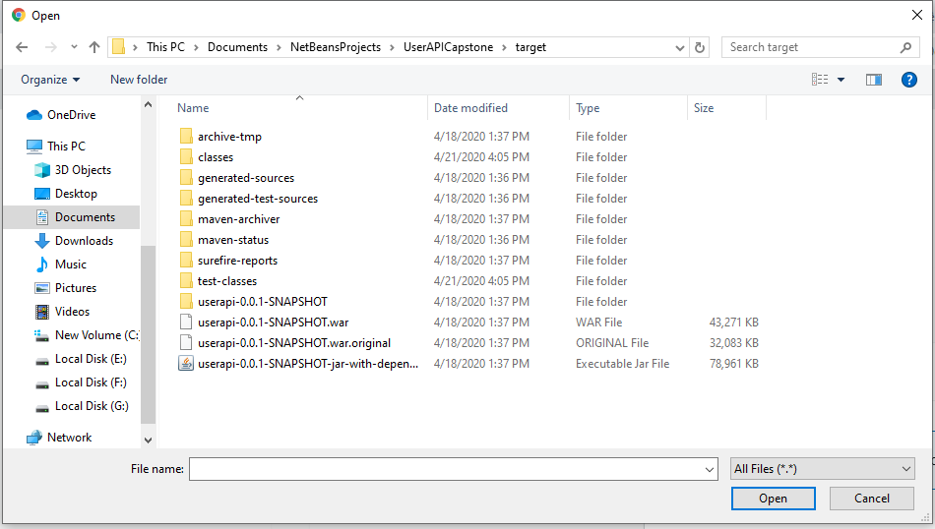

11 Click open and deploy, wait the environment turning green then we can use the application

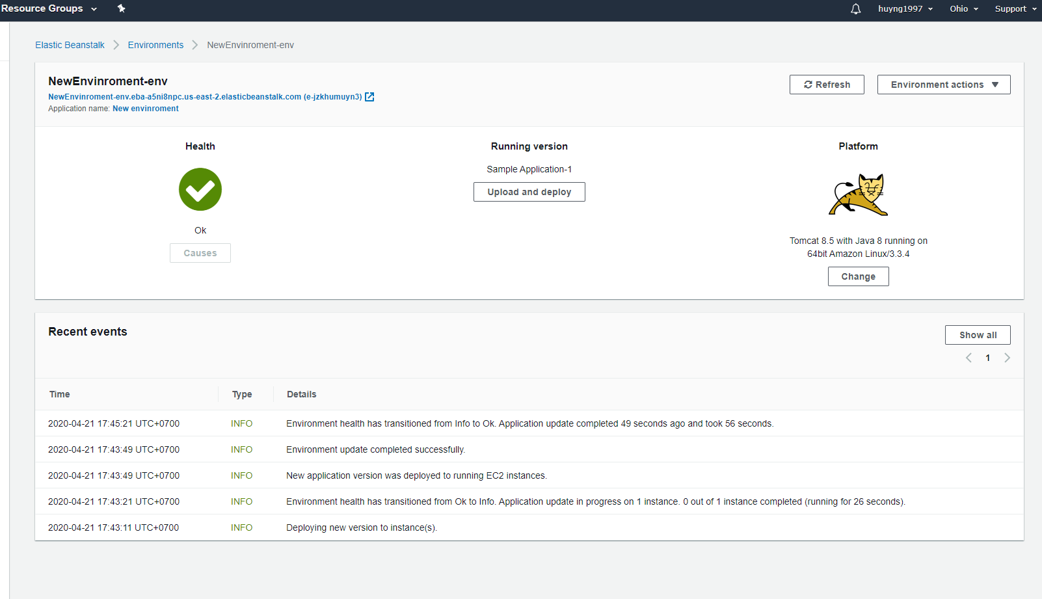

### 1.3 Setting up environment at client side

Web application: Chromes (v28 or higher)

Mobile application: Android version with API > 27

## 2. User Guide

### 2.1 Guest

#### 2.1.1 Find location

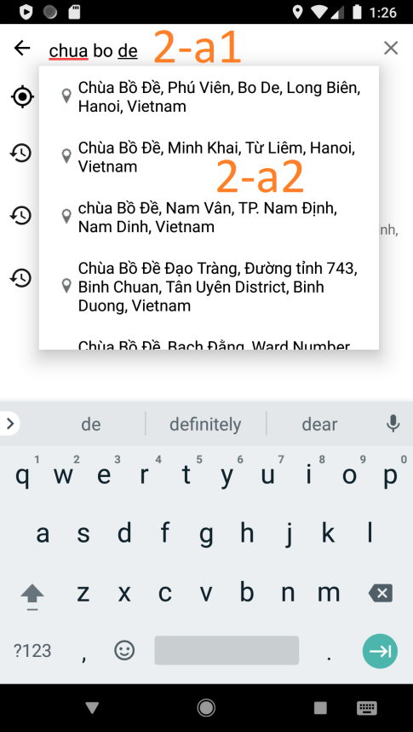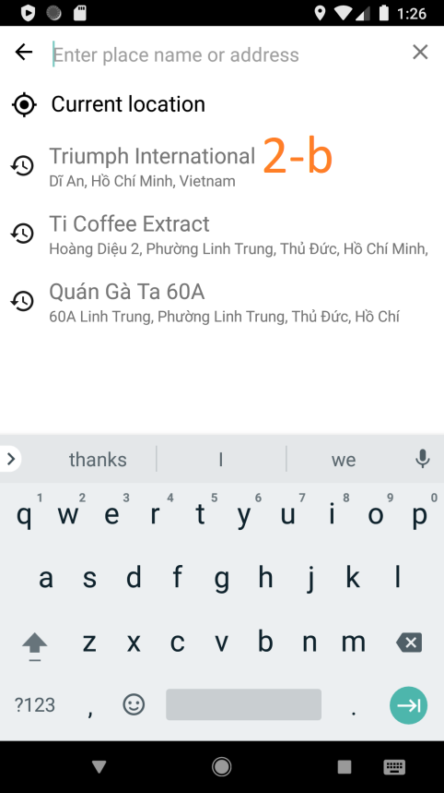

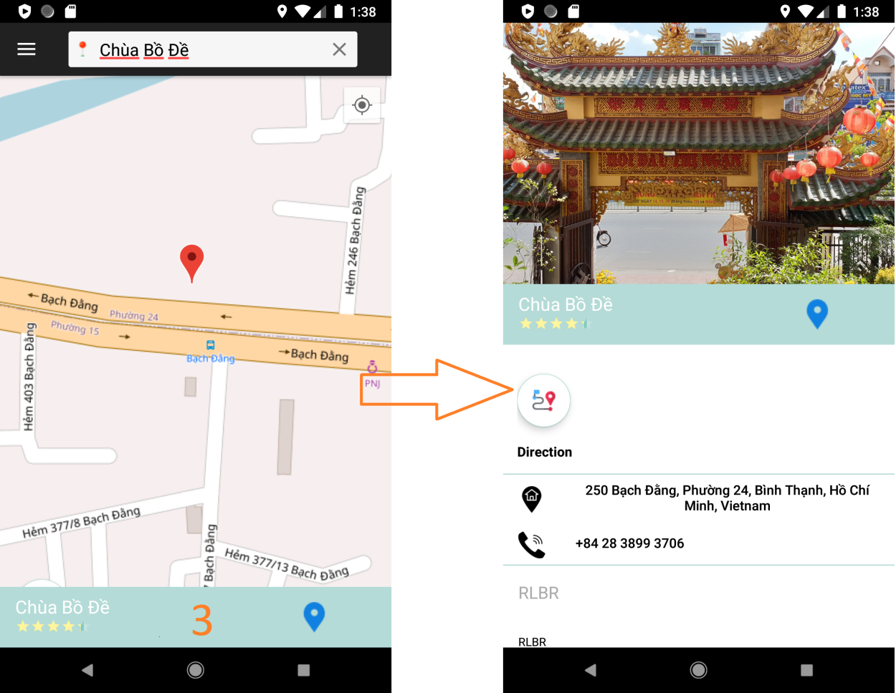

|  |  |
| --- | --- |
| **Step** | **Description** |
| 1 | Tap to Search text field |
| 2-a1 | Input address |
| 2-a2 | Choose suggest item in dropdown-list |
| 2-b | Choose history location item |
| 3 | Swipe up info bar to view Location detail information |

#### 2.1.2 Find route

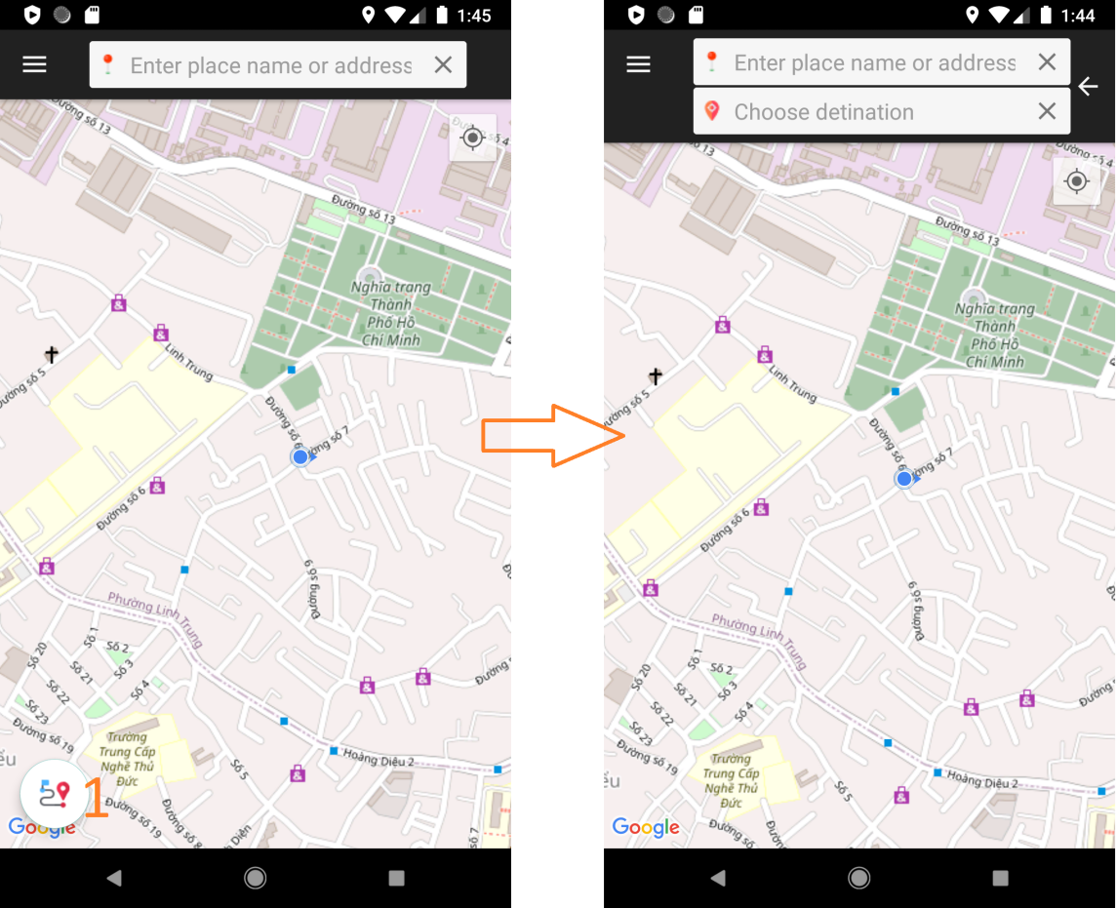

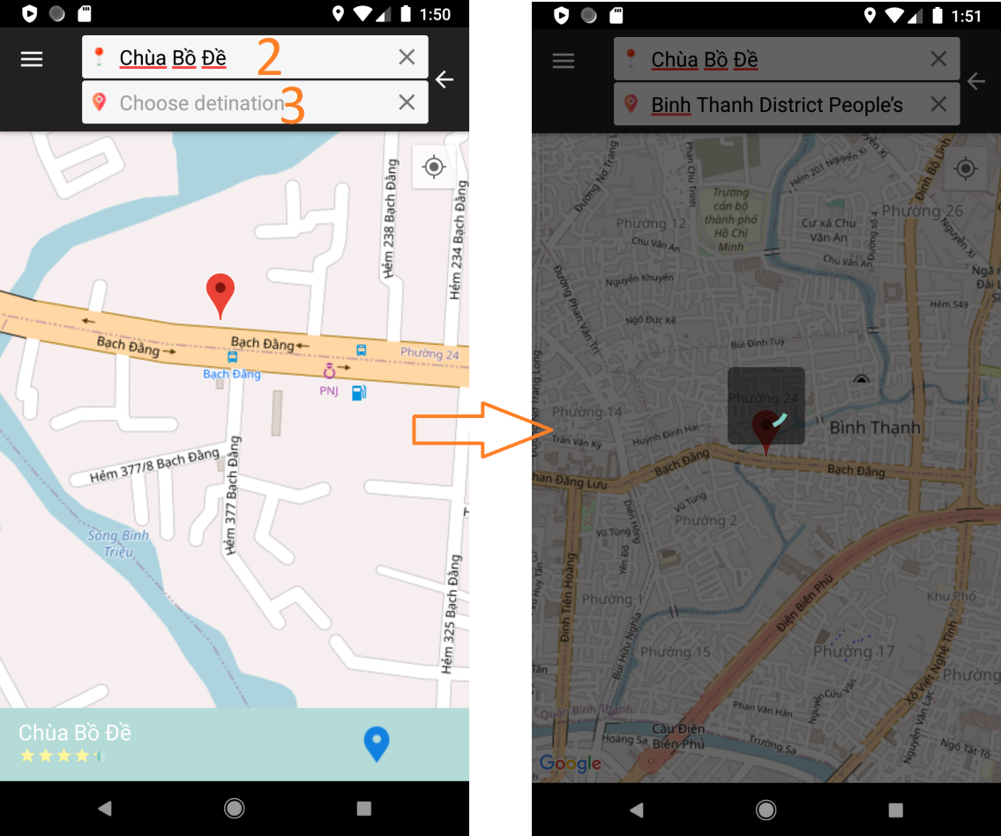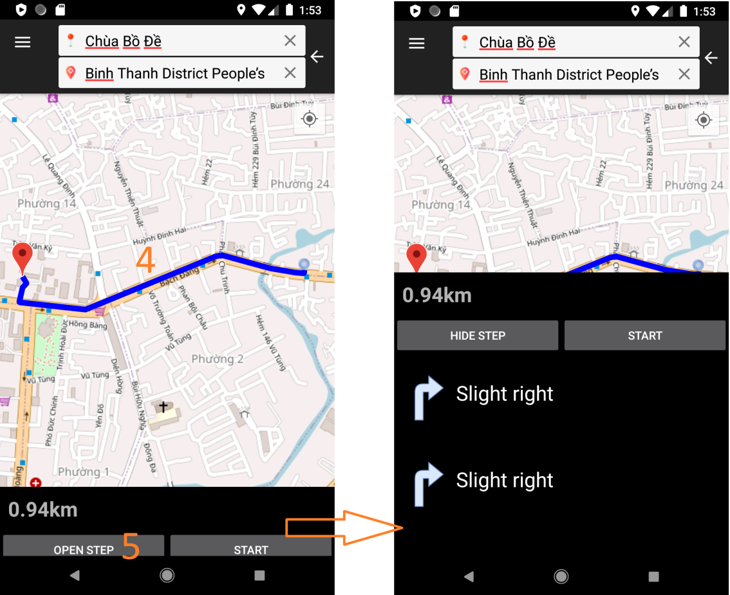

|  |  |
| --- | --- |
| **Step** | **Description** |
| 1 | Tap to Start to find route button |
| 2 | Input origin |
| 3 | Input destination |
| 4 | View route result |
| 5 | Tap to view step by step |

#### 2.1.3 Change route

|  |  |
| --- | --- |
| **Step** | **Description** |
| 1 | Tap to a path of route want to change |
| 2 | Choose Yes |
| 3 | Tap to a new route |
| 4 | Choose Yes |
| 5 | View route result |

### 2.2 Member

#### 2.2.1 Tracking route

#### 2.2.2 Contribute route

### 2.3 Collaborator

#### 2.3.1 Report traffic jam

#### 2.3.2 Cancel traffic jam

### 2.4 Staff

#### 2.4.1 Approve/decline contribute route

#### 2.4.2 Cancel traffic jam

### 2.5 Admin

### 2.5.1 Lock/unlock account

#### 2.5.2 Change Formula coefficient

# **G. Appendix**

1. **ReactJS** *[Online]* Available: <https://reactjs.org/docs/getting-started.html>
2. **Sql Server** [*Online*] Available: <https://www.microsoft.com/en-us/sql-server/default.aspx>
3. **Netbeans** [*Online*] Available: <https://netbeans.org/>
4. **Android Studio** [*Online*] Available: <https://developer.android.com/studio>
5. **Visual Studio Code** *[Online]* Available: <https://code.visualstudio.com/docs>
6. **Firebase** [*Online*] Available: <https://firebase.google.com/?gclid=CjwKCAjwwMn1BRAUEiwAZ_jnEho---uDiSTWw6DevHv8n0lUkx1Ee8XSxDjL9ZfREO_toGDkpYbhRBoClPUQAvD_BwE>